

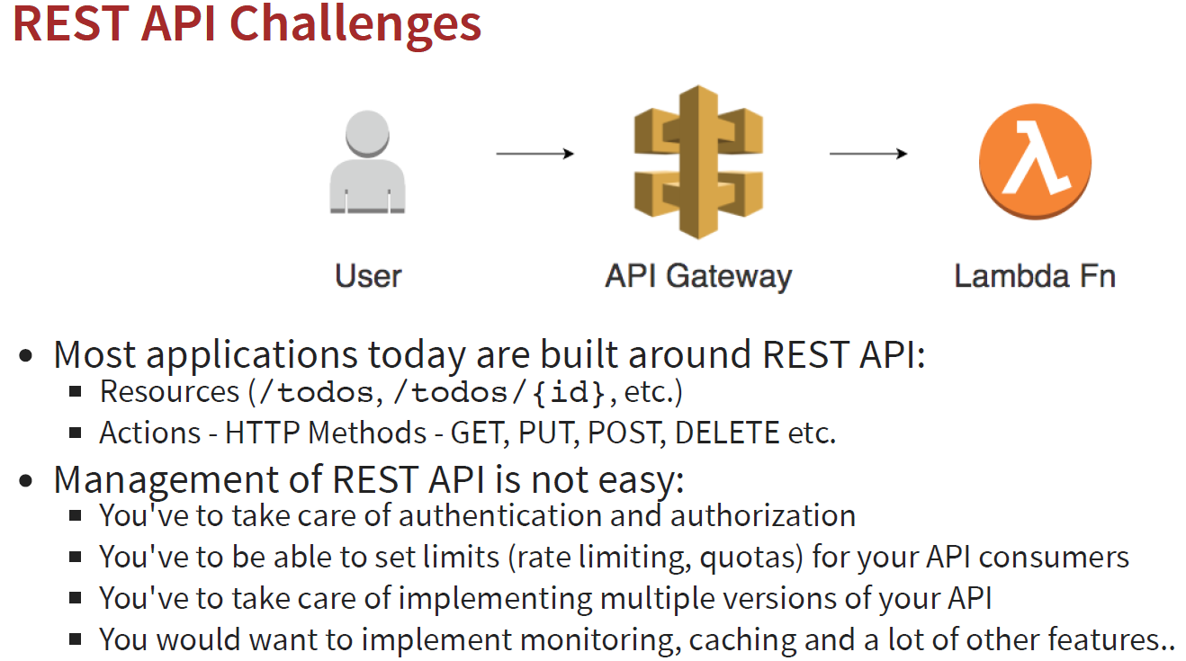

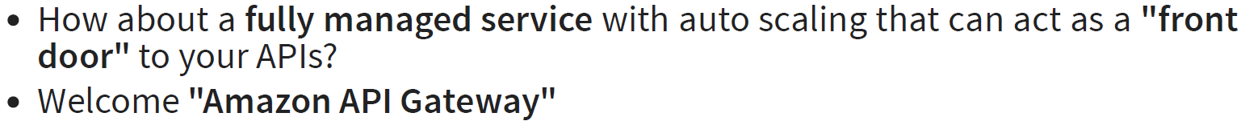

So with the help of Amazon API Gateway we get several features and facilities

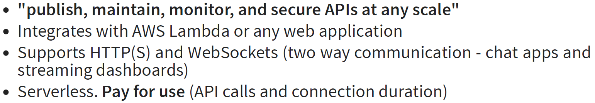

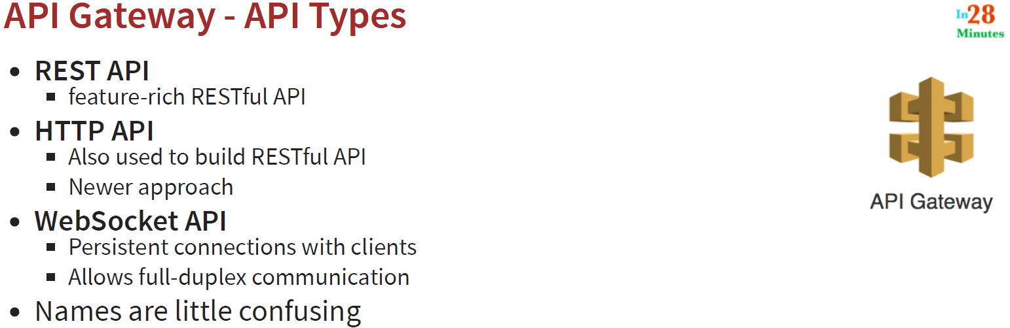

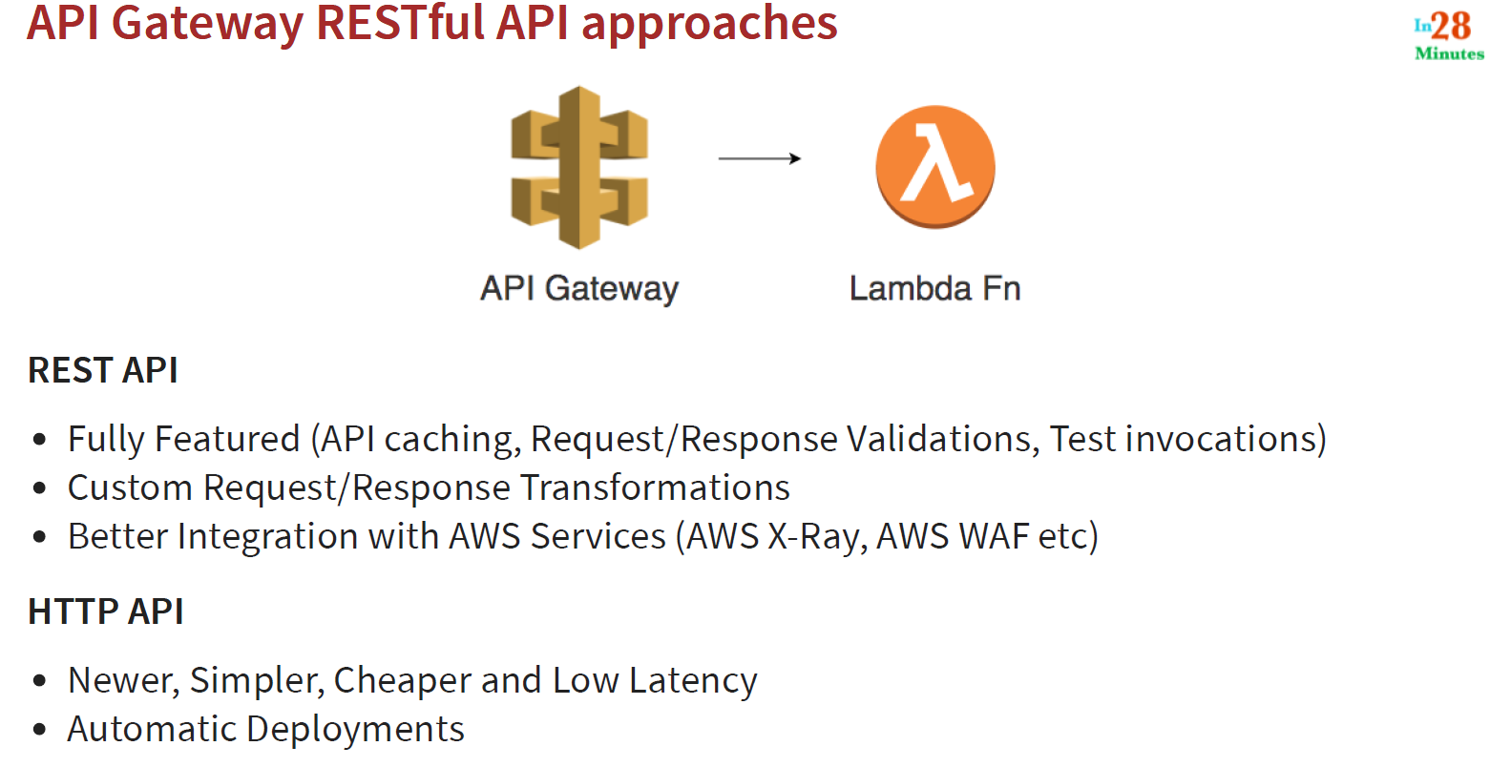

**85. Step 03 - Creating Your First AWS API Gateway - REST API**

- Go to AWS Management Console

- Search for API Gateway

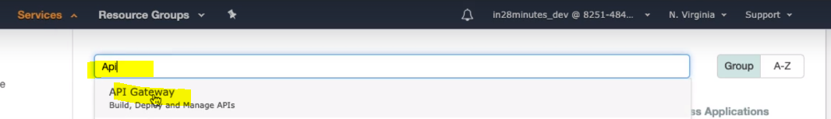

This is used to build deploy and Manage APIs.

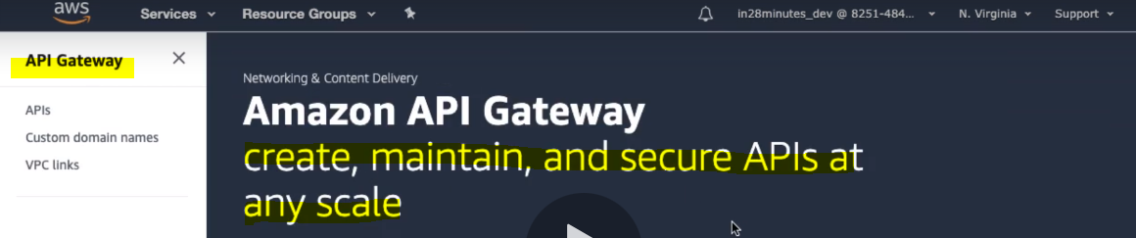

Let’s create REST API

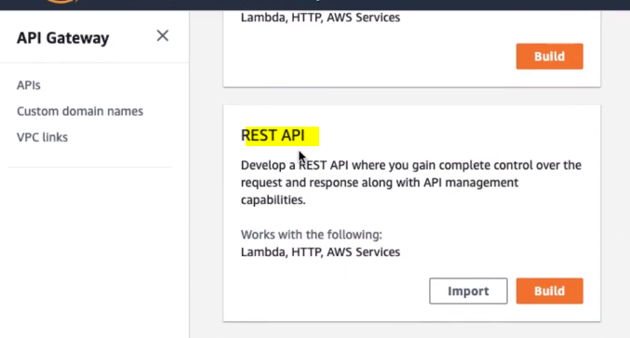

Click on Build:

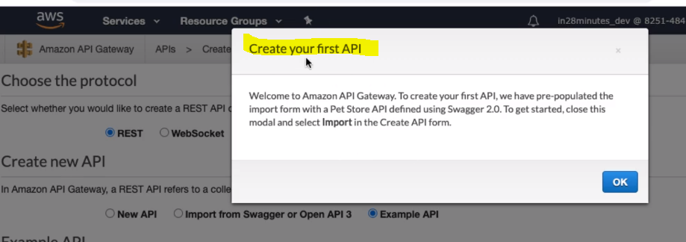

Click ok and we will get the page to create new REST API where we will have to provide the following details.

* Choose the Protocol : REST
* Choose the New API to create new API
* Provide the API name- HelloWorldRest, Description- Optional
* Select the endpoint type Regional or Edge Optimized (it is location present all over the world) or Private
* Click on create button finally

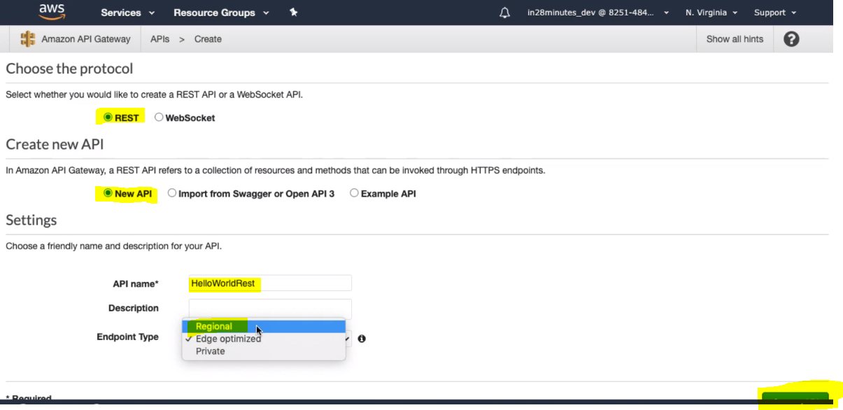

Once we create API we get the Resources and methods to be mentioned for this new API. We can create from Actions:

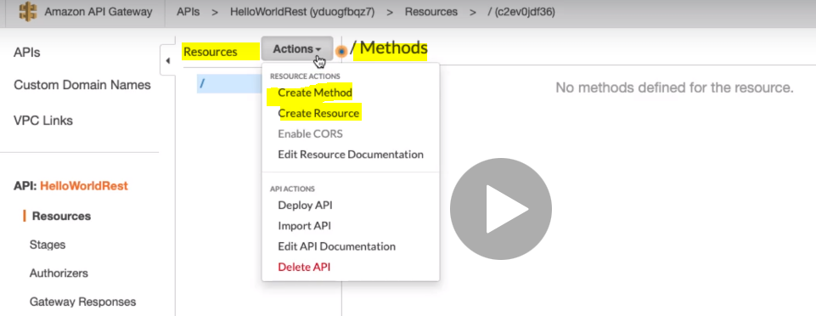

So first let’s create resource: Click on Create Resource:

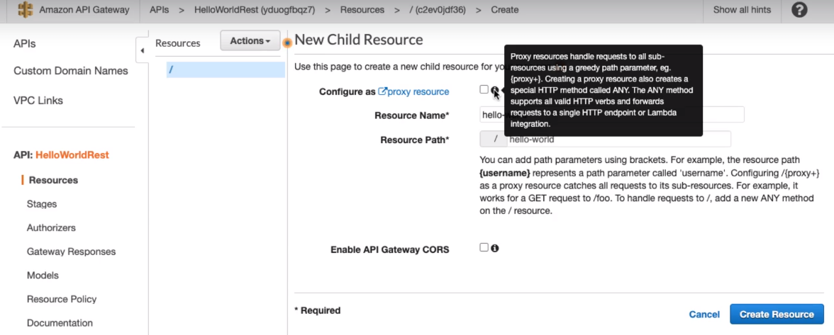

Provided the Resource Name : hello-world and same name automatically it will be mentioned inside Resource Path as well.

Here we can see on Proxy resource check box: if we check this check box then this will handle all the request to all sub-resources using a greedy path parameter:

For example here we have provided the Resource Name: /hello-world

So if check the check box then along with this resource name if any other name is also gets associated (e.g.: /hello-world/ abc ) then it will allows that resource path also.

So if we want to allow only specific Resource name and path then we will not check this check box.

Another checkbox is of (**CORS**) Cross Origin Request Service (to allow access different domains locations) for now we will not enable it.

Finally click on Create Resource:

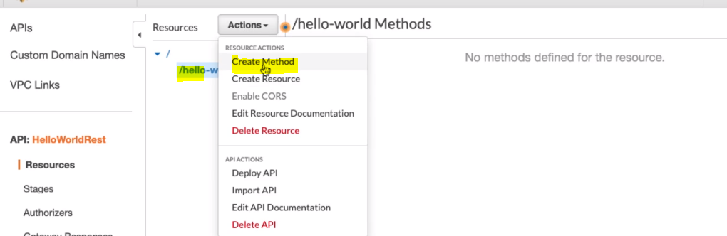

So now we have got Resource (/hello-world) created. Now next, let’s Create Method.

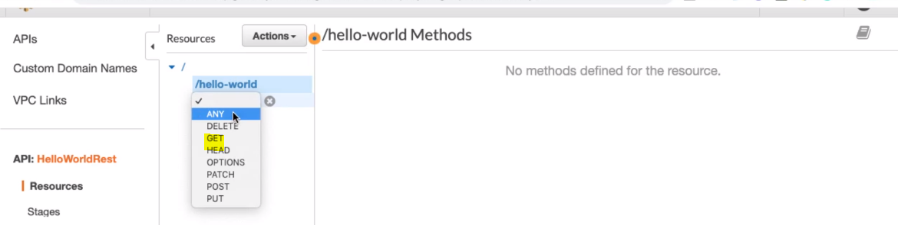

Let’s start with GET method:

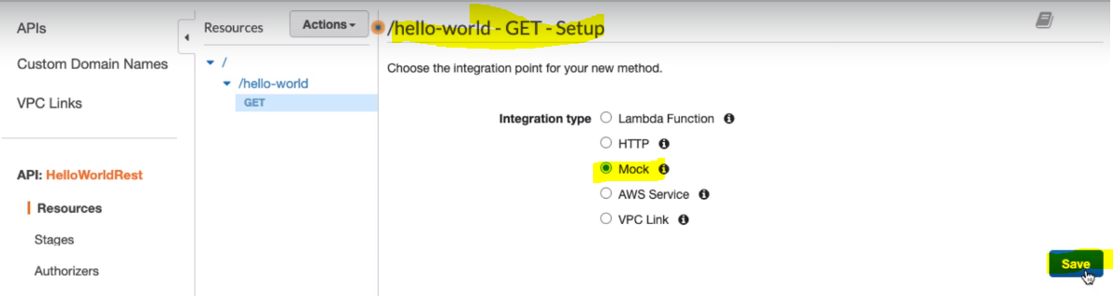

So here we can select any one from the integration type: Let’s first select Mock where we will provide the hard response and mock that. Later on we will see Lambda Function:

Click on save:

Once we save this we will get Method Exaction Interface or page where we will get four stage of the Method Execution.

1. Method Request
2. Integration Request
3. Integration Response
4. Method Response
5. And we have one Mock Endpoint

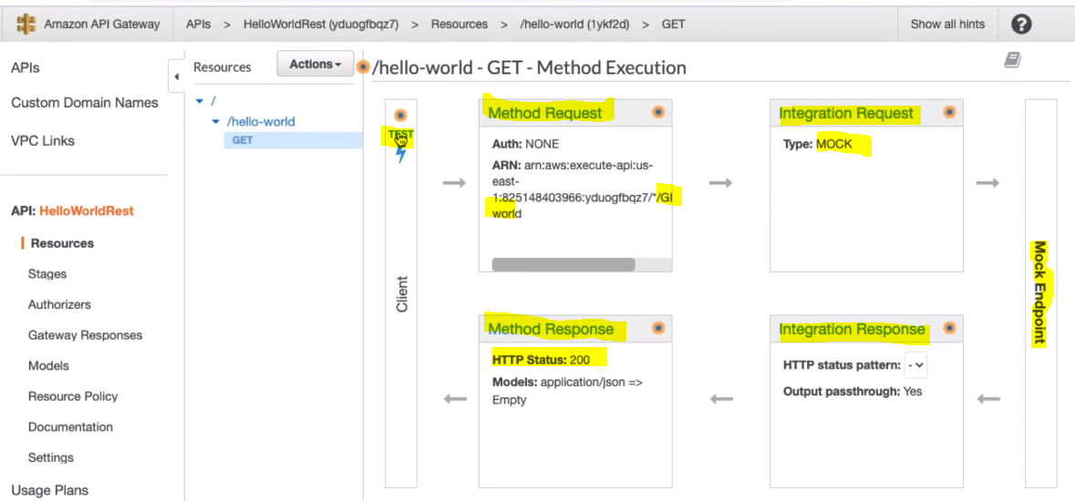

**So far we have not provided any hard data: So if we Test now then we will not get any response: let’s test and check.**

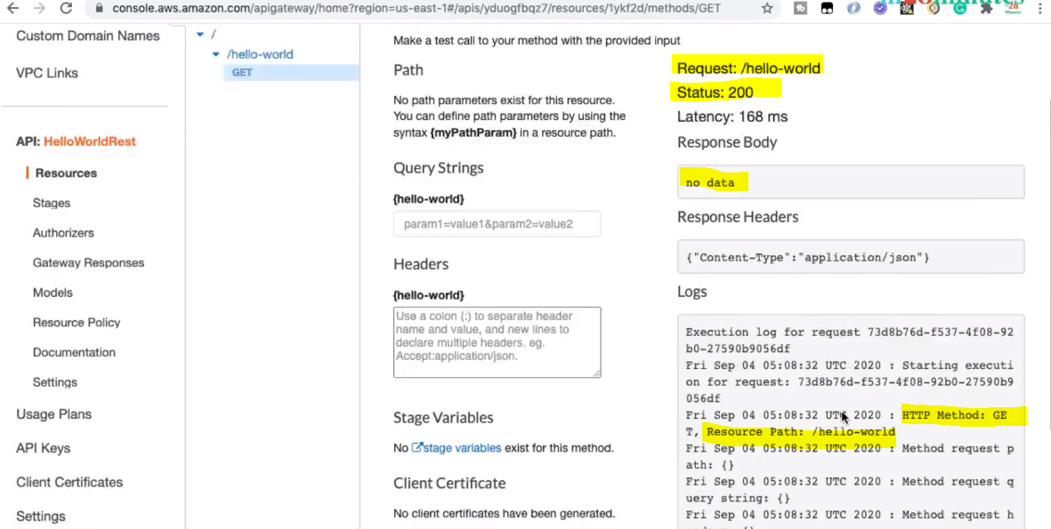

**So here we can see the Request, Status and Response Body where we are getting no data because we have not mentioned any mock data. And below we are getting the logs.**

Let’s talk about the all four Boxes

1. **Method Request:** It is all about the request coming in

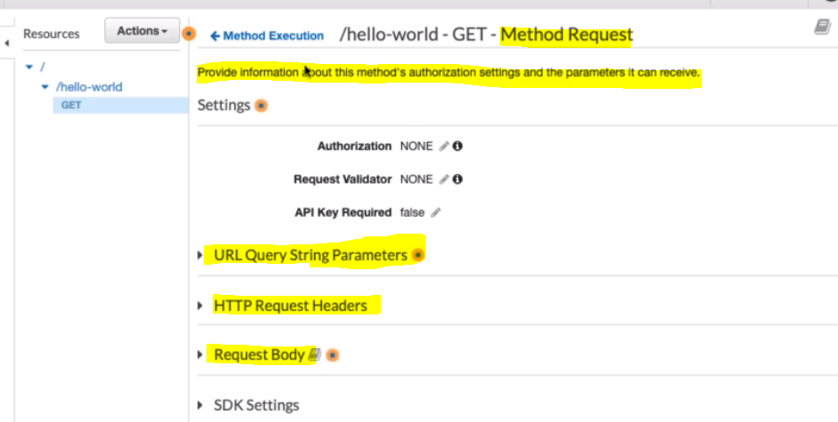

So as per the above image method request provides the information about method’s authorization settings and the parameter that it can receive.

We can set or add additional values like

1. Query String
2. Header Request
3. Request Body

After setting this request once we hit this then it is handled by integration endpoint – which is [**Mock Endpoint**]

1. **Integration Request:** It is all about transforming the request before handling by integration endpoint:in other world if want to modify our method request in some other format before handled by Mock Endpoint then those transformation is done here in the phase.
2. **Integration Response:** Once Integration endpoint process the request and provide response then here in the Integration Response we can transform the response according to our need.
3. **Method Response**: This is nothing but the response which goes back to the client.

**87. Step 05 - Playing with AWS REST API Gateway - Customizing Mock Response and Head**

In the previous step we have discussed about all the four steps at high level. In the above example when we test then we did not get and response because we have not configured the mock data in the response. So now let’s configure the response to get response. We will configure this response in the **Integration Response** Phase.

Click on third: Integration Response link:

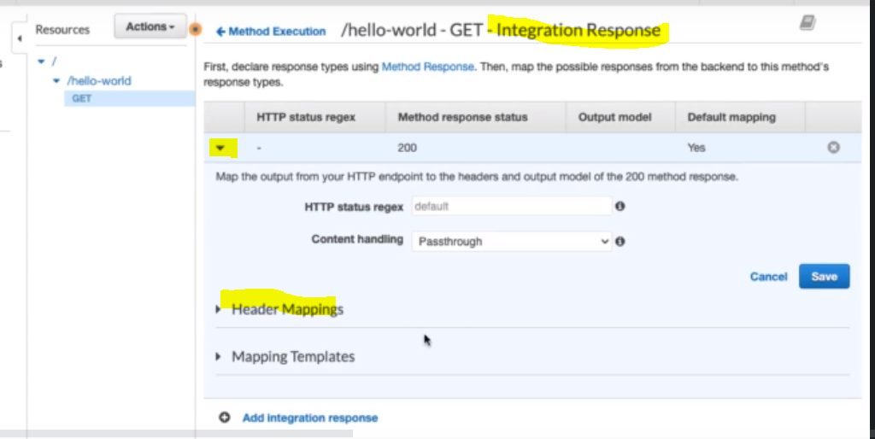

**Now expand the Mapping Templates and in the generate template select Error and add our own custom mock response.** 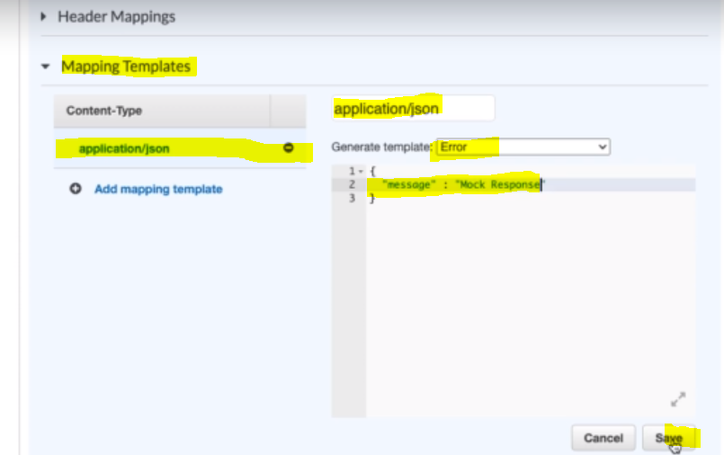

Now click on save and test it:

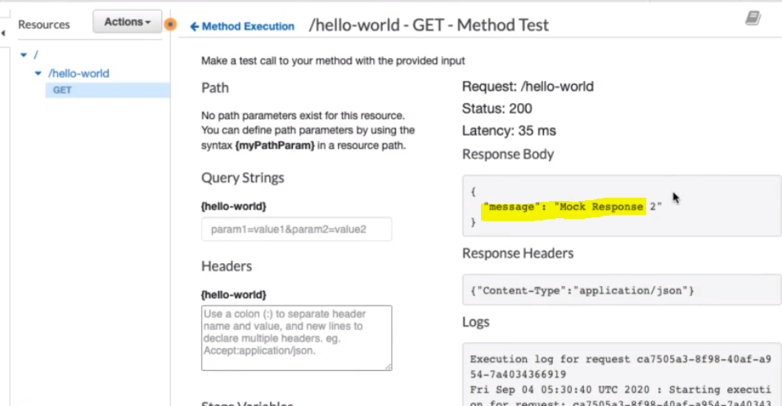

Now when we test it we start getting response in the response body.

Apart from response body we can set the header also.

First let’s define response structure in the Method Response stage and same header then will be available the Integration Response and here then we can set the header.

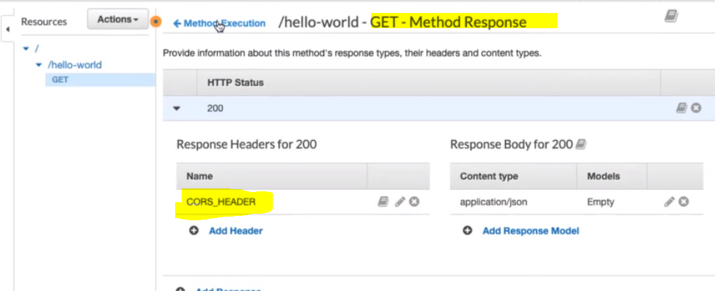

Now let’s go to Integration Response:

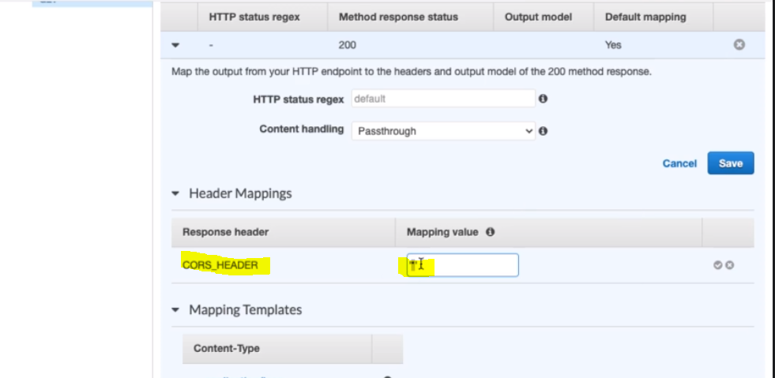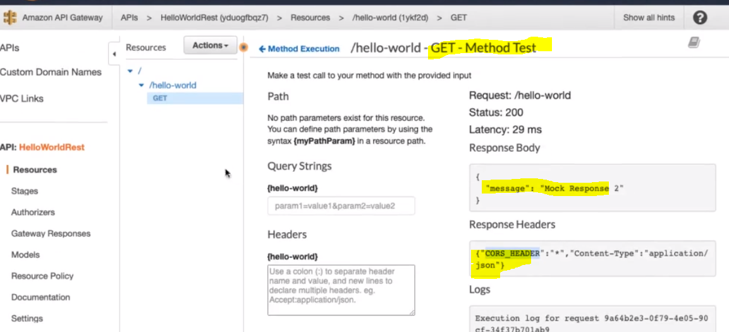

Now we can see the header also in the response when we test it.

So in this way we can map the request and response accordingly. Now next let’s try to map request and response in the Lambda function.

**88. Step 06 - Integrating AWS REST API Gateway with Lambda Integration**

So here when the request comes to API Gateway then we want to execute lambda function. And to be able to do that first let’s create the lambda function.

* **Goto Amazon Management Console and search for** Lambda

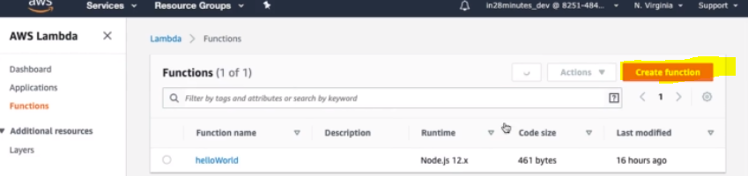

* **Create a new function**

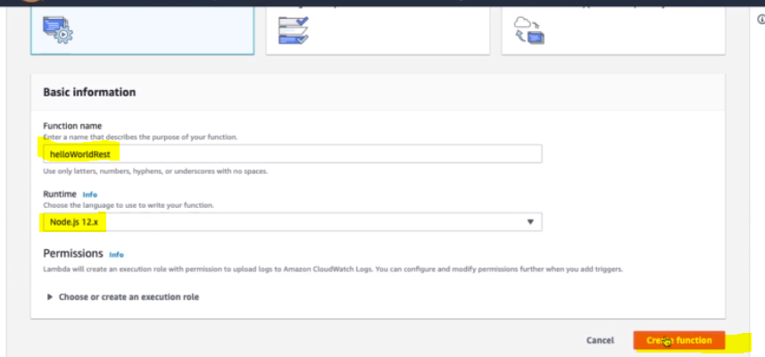

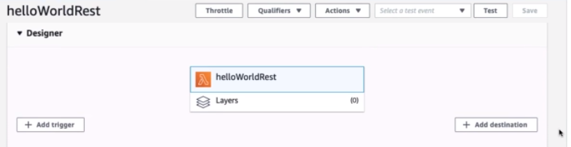

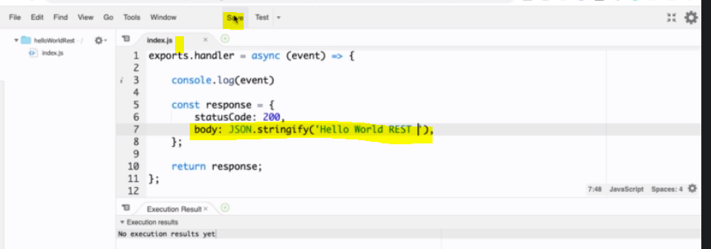

Save and Test : Configure the test event

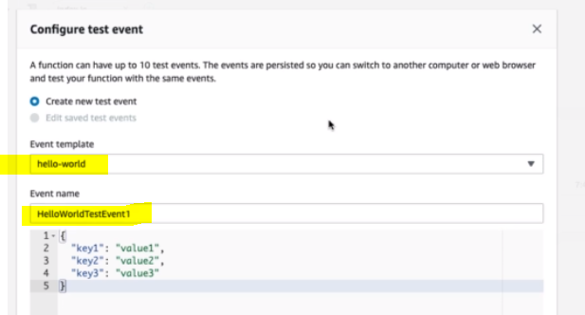

* Click on create in the below:
* Now when we test it again the we will get the log:

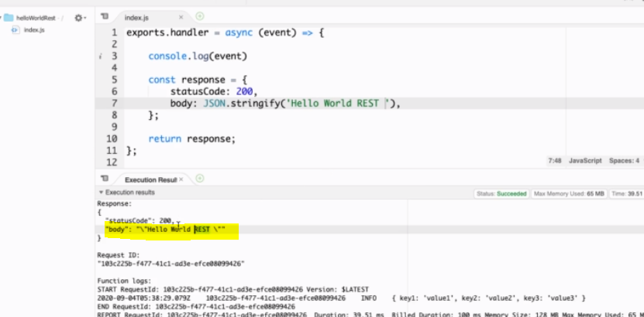

So this way we have created the lambda function and now let’s call this lambda function through AWS API Gateway.

* To be able to do that let’s goto AWS API HelloWorldRest gateway

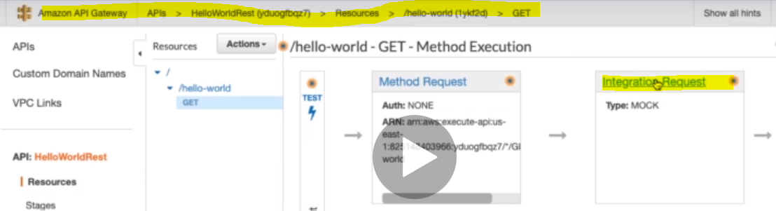

* Go to the Integration Request and here instead of choosing Mock, let’s choose lambda

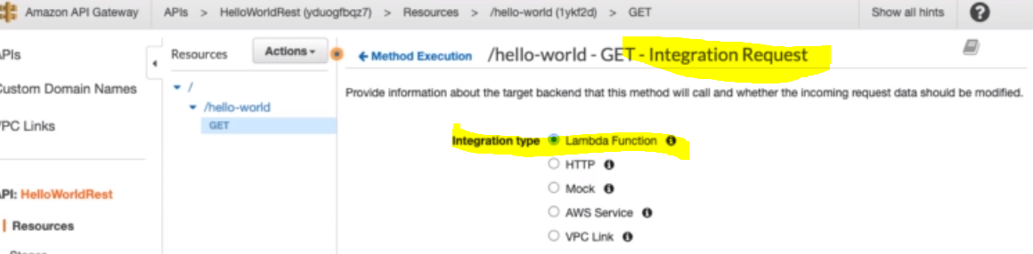

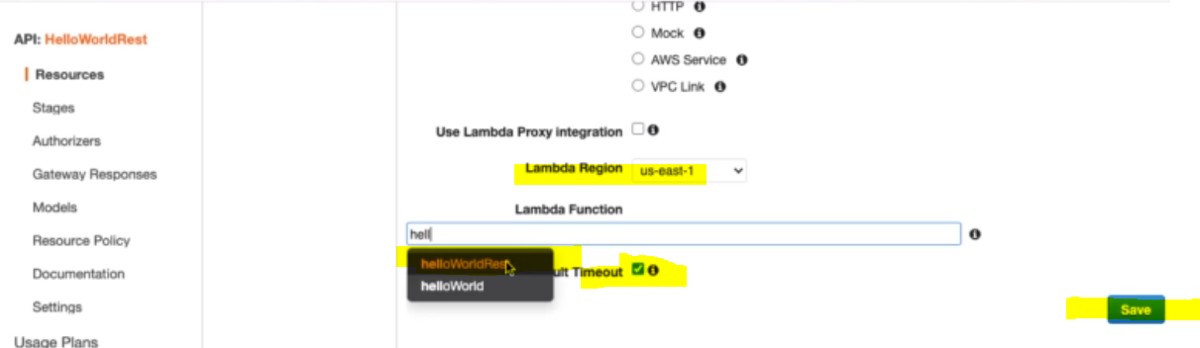

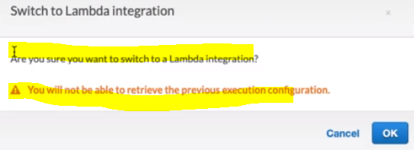

So here we are switching from mock to lambda that is why we are getting this warning. Let’s click OK.

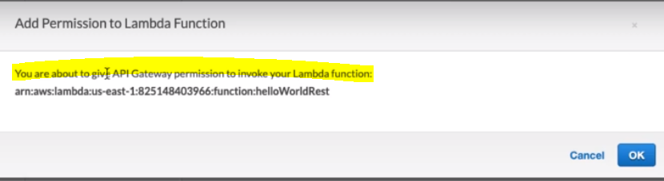

Since API Gateway is different resource or domain and lambda function is different resource or domain. And in AWS if one resource wants to talk to another resource then it needs to have access or permission to it.

Now let’s go back to method execution: Go to test and test this lambda function through API Gateway. 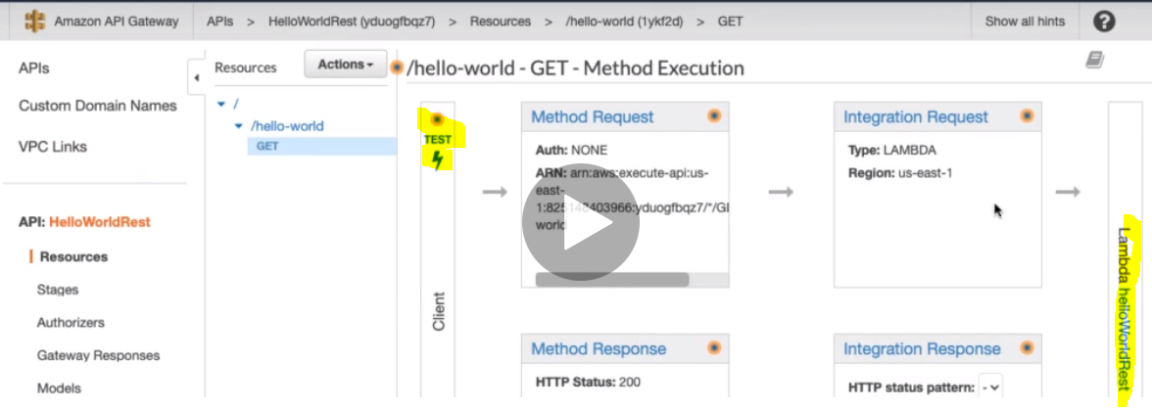

Here we can see the endpoint as a **Lambda helloWorldRest** : Click on test to test this

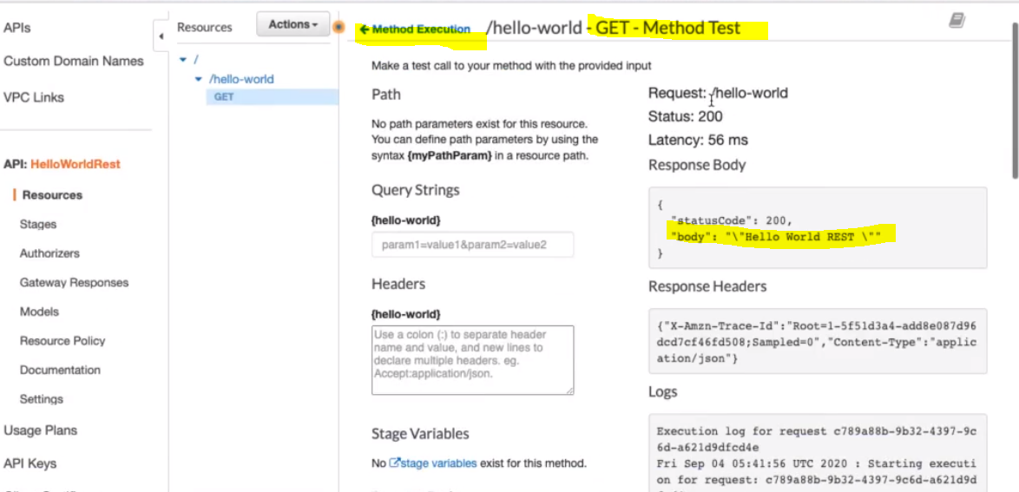

So here we can see that we are getting the response from the lambda function. Now let’s do some modification in the lambda function and test it again from API Gateway.

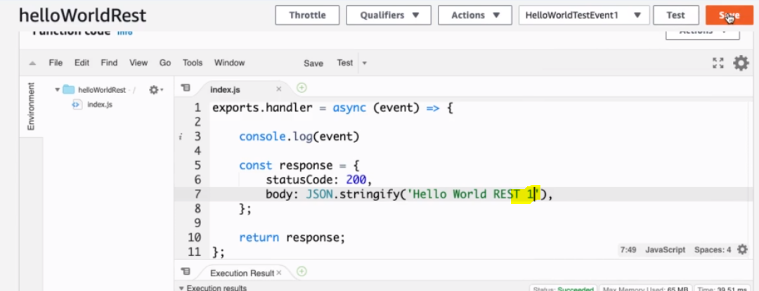

Now Goto API Gateway and test this.

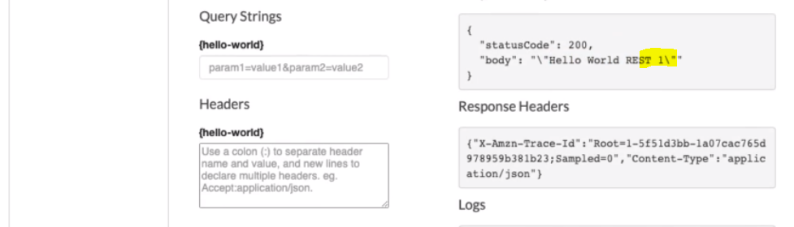

So here we are getting the modified response.

So in the last two steps we have got to know the integration of API gateway with Mock data and lambda function.

Now in the next step let’s map the Request header and then test.

**89. Step 07 - Playing with API Gateway - Using Mapping Template to map Request Header**

In the previous step we have executed lambda function successfully from an API gateway and we were able to see the response coming from the lambda expression.

Now in this step we will pass few parameters (Query Strings and Headers) to the lambda function and we want to be able to see these values in the lambda function.

|  |  |
| --- | --- |
|  |  |

So here we would add parameter in the query String and Headers and pass the same to lambda function and in response also we will display the same. Since we are playing with Get request method that is why Request Body will be empty.

Query String: [query1=query-value1 & query2=value2]

Headers: [ header1: header-value1

header2: header-value1 ]

**Note:** So we can see the difference of passing Query String parameter and headers as parameters. In the QS the value is assigned using (=) and two QS is separated by &

While in case of headers: parameters values are assigned after (:) and multiple parameters can be separated by enter (next line)

Now let’s try to access these parameters in the lambda function so that these also could be the part of get request when will hit lambda function. So to pass this parameter to lambda function we will use “Integration Request “of Method Execution.

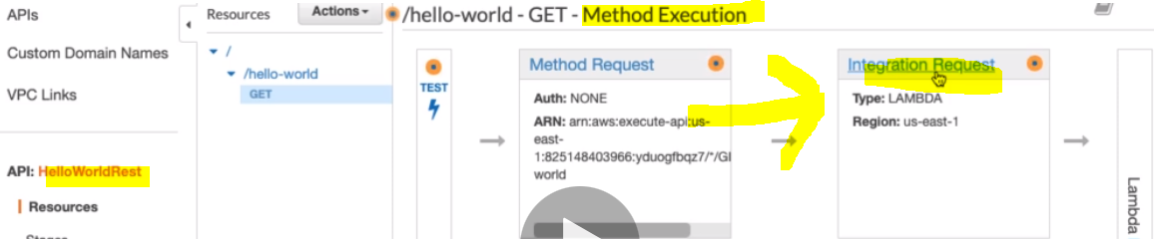

So here we will map Method Request QS and Header parameter to the Integration Request:

* Go to Integration Request.
* Scroll down and go the Mapping Templates.
* Select ‘When there are no templates defined (recommended)
* Click on Add Mapping Template

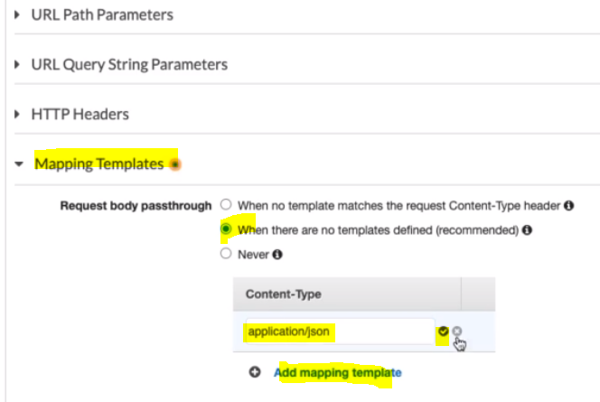

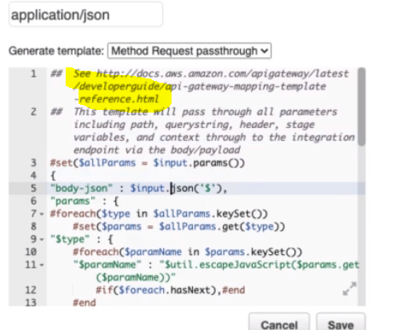

Once we select the Method Request pass-through we will get pre-defined template given by AWS.

Now let’s go back to Method Execution and Test.

Once we test this to verify let’s go to Lambda function and check their latest log under cloud watch section.

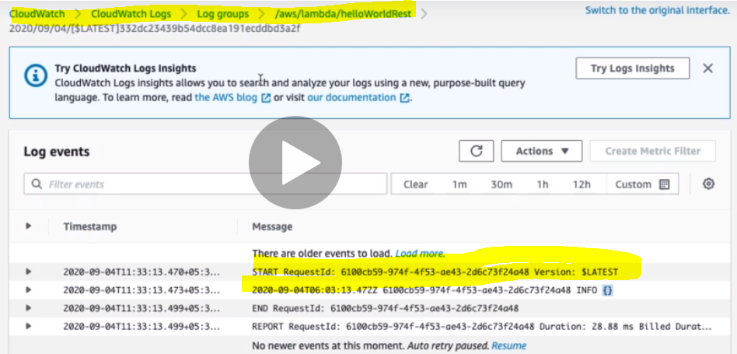

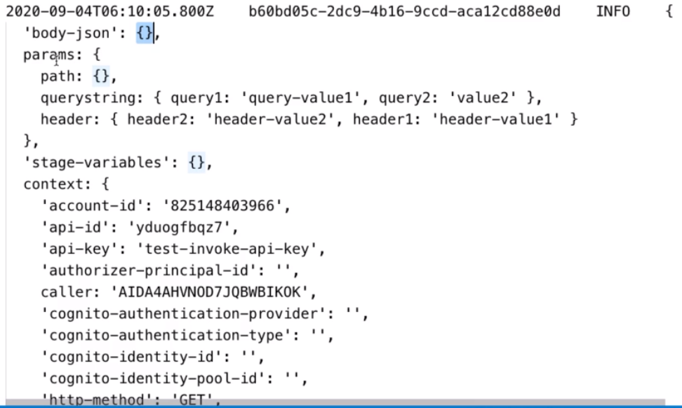

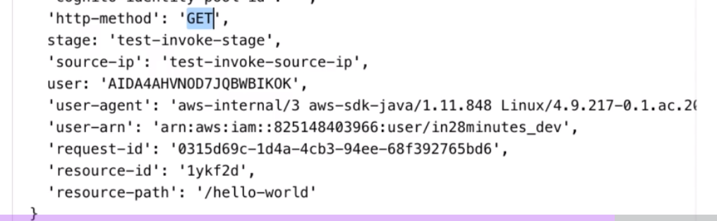

**The above values can be accessed using the below command mentioned in AWS Template**

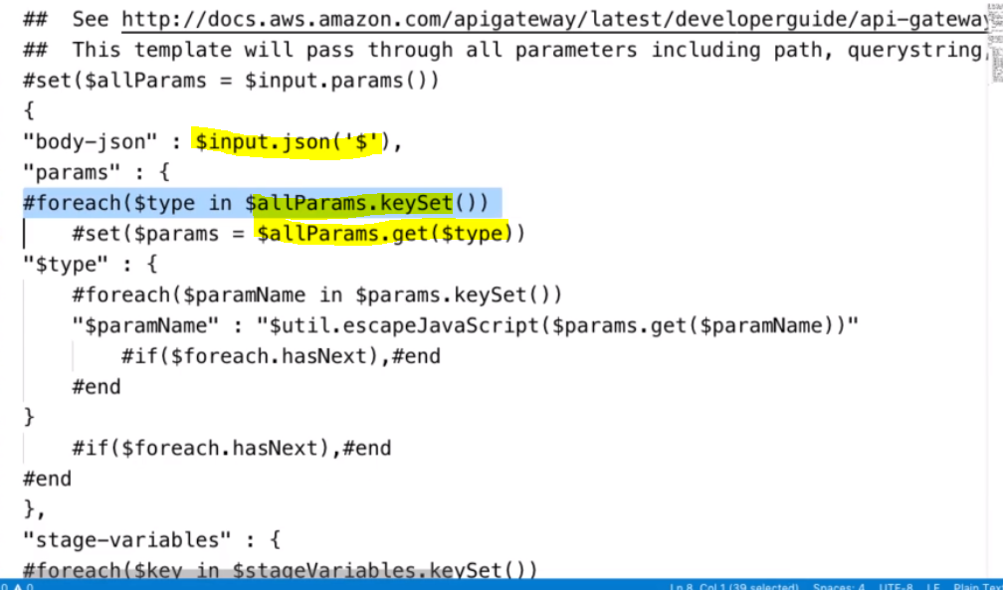

Note: typically we don’t need to get every values so let’s modify the above template to get particular request:

|  |  |
| --- | --- |
|  | So now we can see only body json and params.  So in this way we can modify the template according to our need. |

In the lambda function we can access the values of parameter set in the API Gate way Method Execution. Using logs

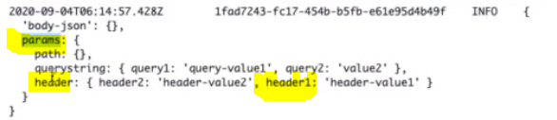

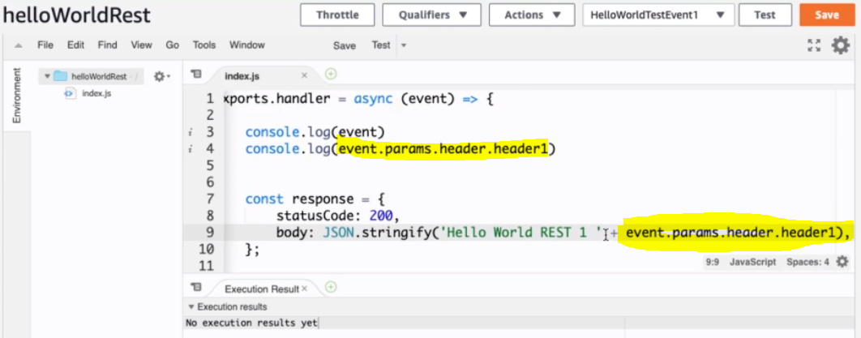

Now it would be the part of response also when we hit from API Gateway.

Now let’s go to method execution of API Gateway and Test the Get method once again.

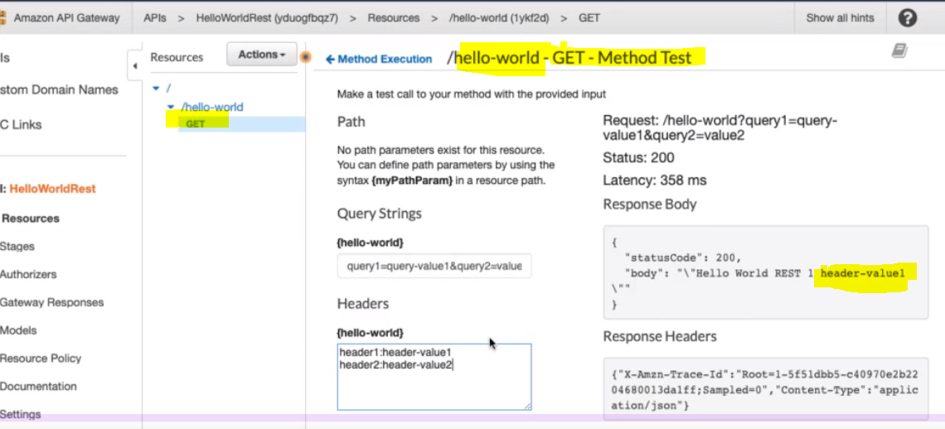

Hence we can pass the parameters from the API Gateway and can use in our lambda function and using event we can access these parameters values and get the result accordingly.

**90. Step 08 - Playing with API Gateway - Creating POST Method**

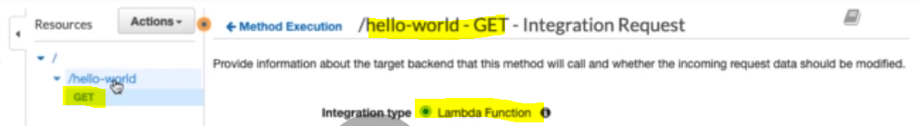

In the previous step we have used Get method and integrate Lambda function.

Now let’s play with the POST method. To create Post method :

* First select the /hello-world
* Go to Actions : Click on Create Method
* Select the Post method from the drop down

|  |  |
| --- | --- |
|  |  |
|  | 1. Will go with lambda function once again. |

Here we will use the same lambda function what we have used for Get Method in the previous step.

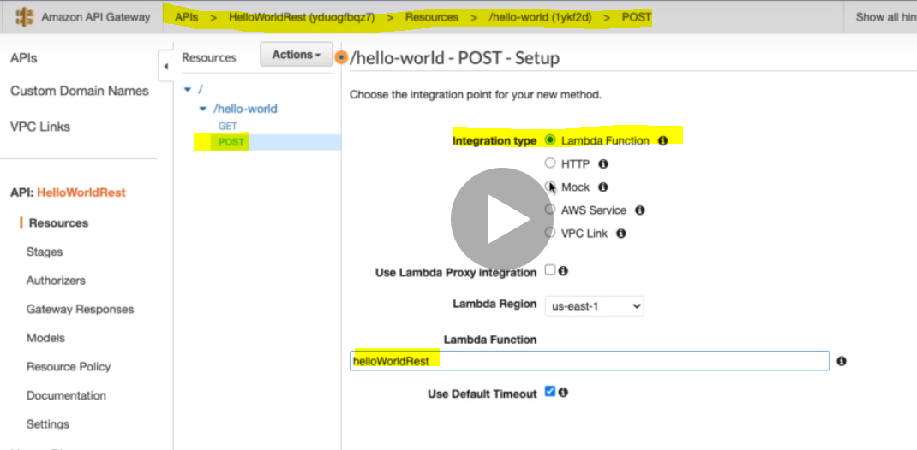

Here as soon as we type the lambda function name its start populating . Click on Save

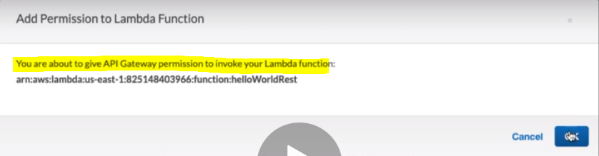

Give the permission. Click Ok and we get the below Method Execution steps:

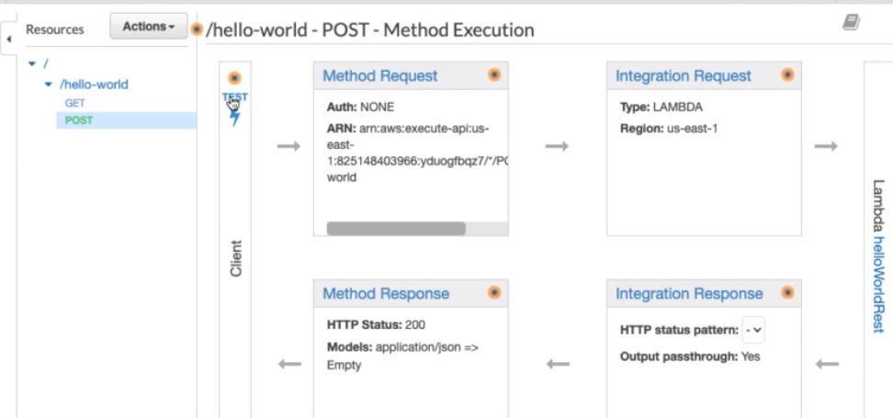

Let’s provide the Request Body In the Test:

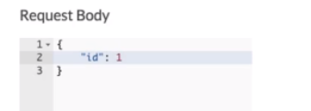

Let’s Test it.

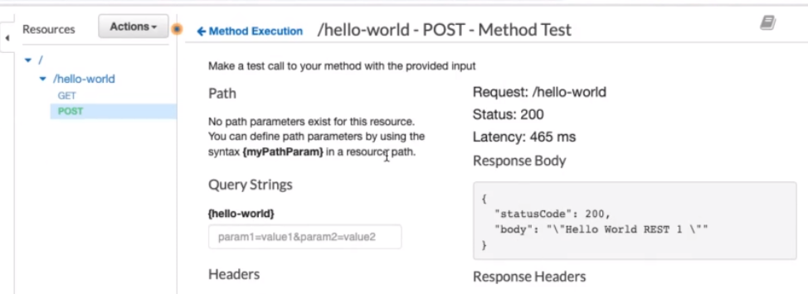

So here we are getting the response but we interested to see the event that lambda function receives. So let’s check the lambda function log under cloud watch.

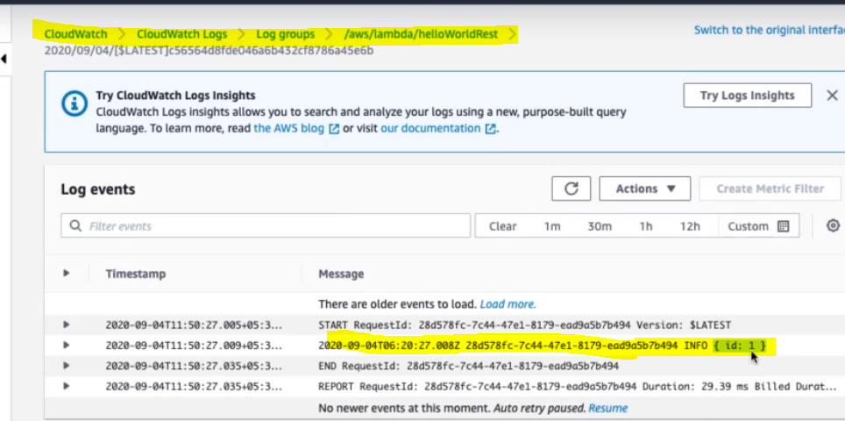

So we can see in the log that we are getting event value in the Lambda function log. Now to more confirm let’s send the description also in the request body along with id: and check again after test in the lambda function log.

|  |  |
| --- | --- |
|  |  |

Click on Test and check the log again.

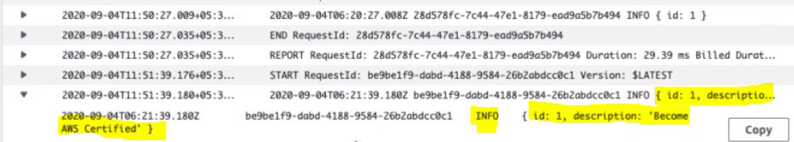

So yes we are getting the request body value in the log.

Case-: Now instead of returning hard code response let’s return the event that lambda function receives and return the same in the json format.

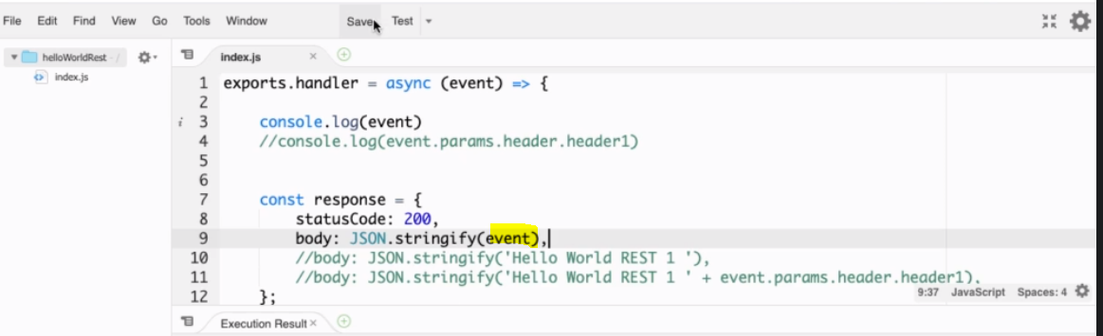

Now let’s go back the API Gateway and test it again:

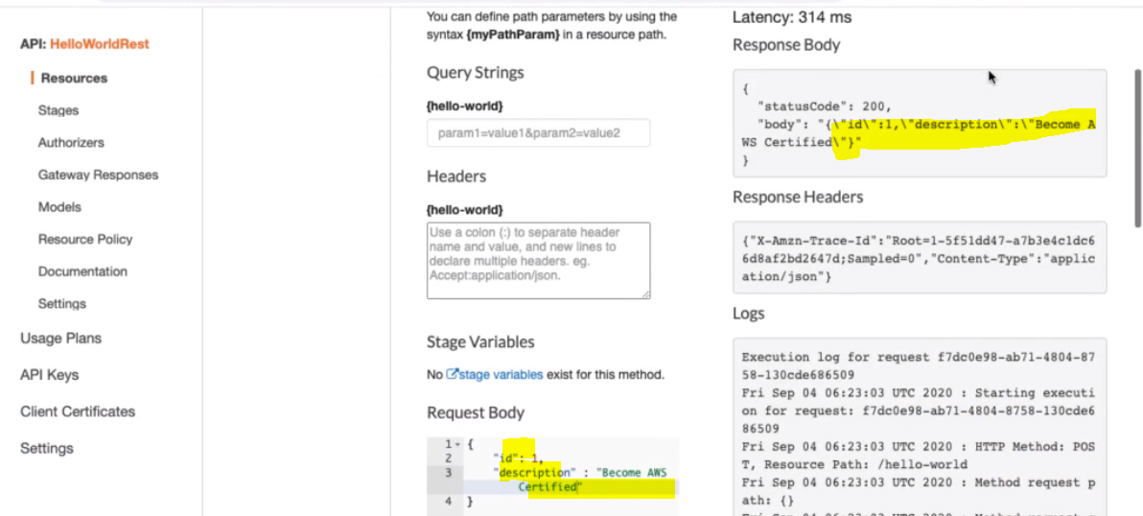

So now we can see the same in the Response Body what we have sent in the Request Body.

Now let’s do some change in the Request body and test again and see the response again. Let’s give the id =2

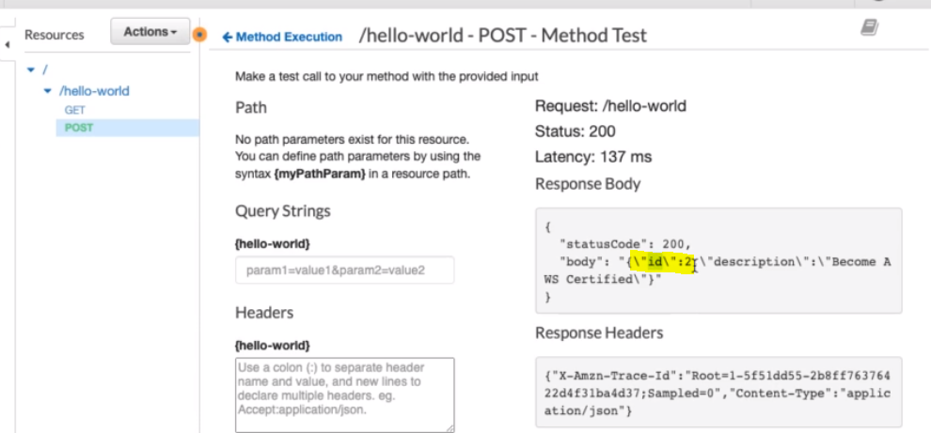

So we can see that it working as expected, we have created the Post request and in the post request we are sending the Request from the API gateway and same request body is received by Lambda function in the event form and in the lambda function we have send he response body. In the next step we will validate these request and play with them.

**91. Step 09 - Playing with API Gateway - Validation Request Body using Model Schema**

Here in this step we will validate the Request body create and configure in the API Gateway to send as request in the Lambda function. How to validate the Request body?

To validate the Request body, we need to define the Request Structure.

To define the Request Structure first go to Models Present under API on LHS side bar as link.

When we go inside this model then we get the couple of pre-defined models [e.g. Empty and Error Models]

Model for Empty Object:

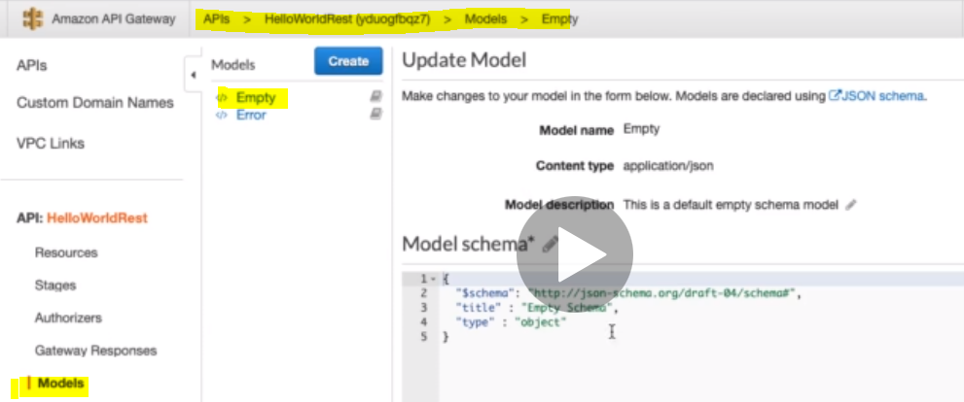

Model For Error Object:

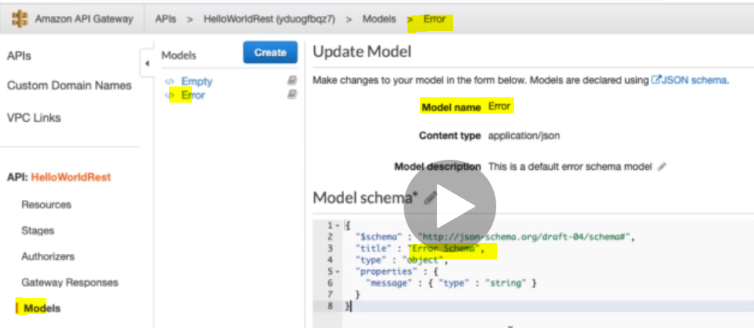

Now let’s create our own Model for Our own Object. Click on Create button marked in blue.

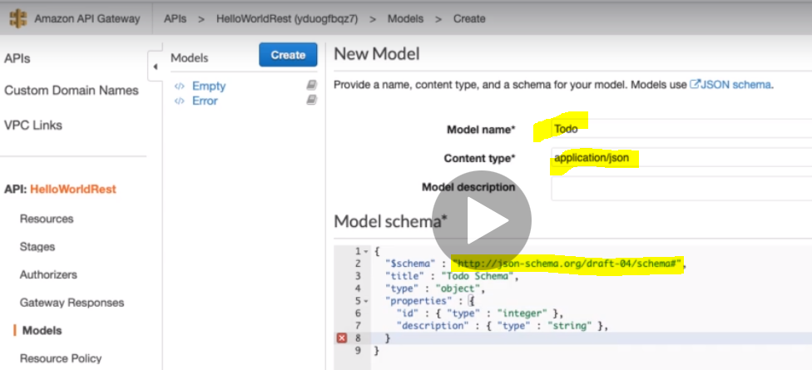

As here we can see that to create Model schema we have some rules to define the variables and its type that we can get the detail from the link $schema : “**http//json-schema.org/draft-04/schema#”**

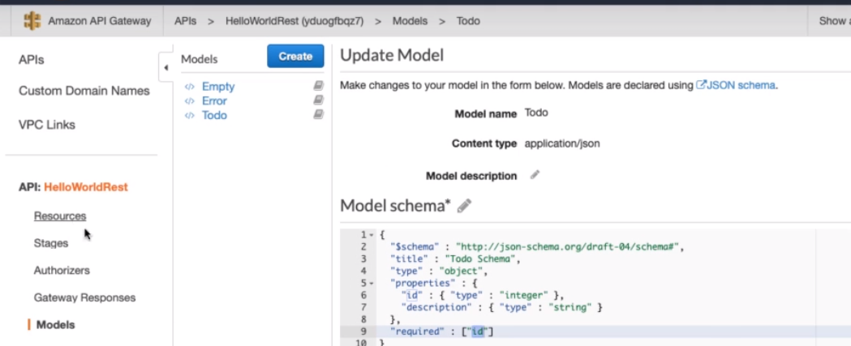

So here we have created Model – Todo whose content type – application/json and Model Schema we have defined in the box below.

Now let’s use this schema to validate our request. And for that

* Go to the Resources under API present in the LHS side bar
* Go to its post method that we have already created
* Let’s configure the validation in the Method Request of Method execution

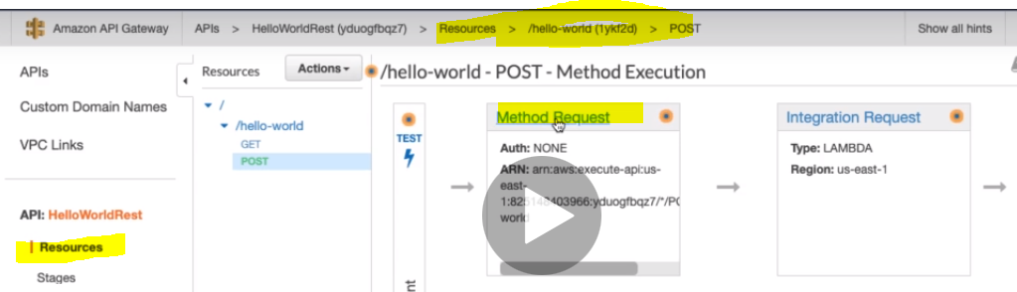

Click and go inside the Method Request

Go to its Request Body section

Select the content type and model name that we have created above.

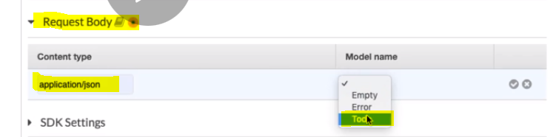

After this we need to enable the Request Validator present in this page in the above section.

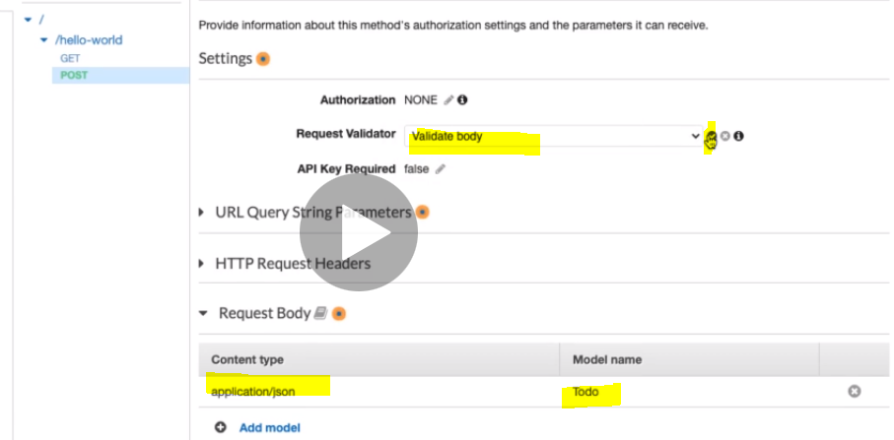

Now let’s execute and test this method.

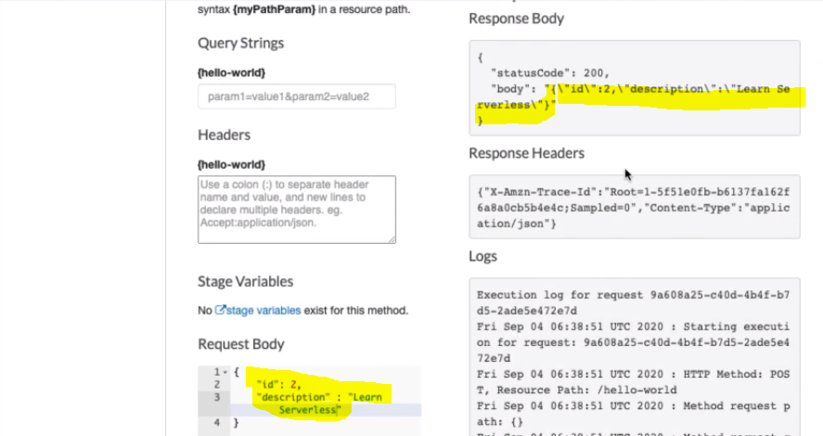

So we are getting the result as expected after request validation. Now let’s remove the id from the Request Body and test.

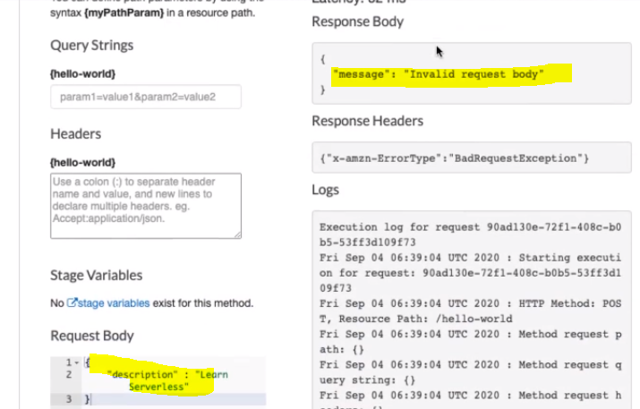

So we are getting Invalid request body because whatever the model we have created for validation could not validate this request body as id is not available. And in the Response Headers, getting BadRequestException. And in the log below we get messages like: Request Body does not match model schema for the content type application/json: [Object has missing required properties ([“id”])].

So in this way we can create the validate model and can validate request by using API Gateway.

**92. Step 10 - Playing with API Gateway - Customizing Response Headers and Validation**

In the previous step we have configured model to validate our request body, in this step we will talk bit more about validation.

The first thing: **Customize Response Body and Response Header:**

In the previous step we are getting from AWS by default but we can configure according to our requirement. So to configure

Go Gateway Resources under API LHS Side bar:

Select the Bad Request Body (which we want to customize) and click on its edit button.

Here in the below section we can configure Response Status code

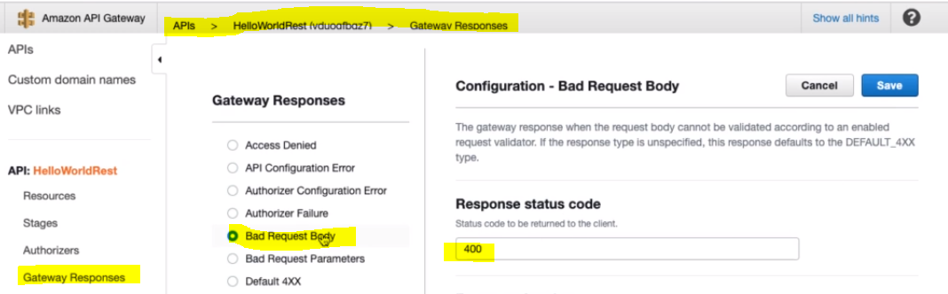

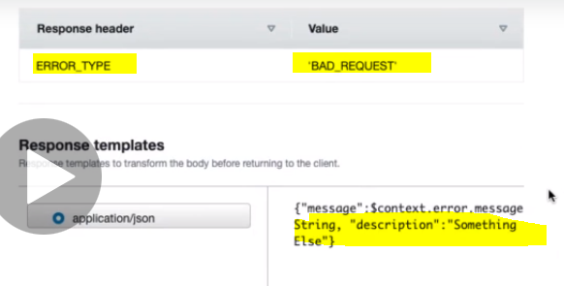

Finally Save:

Now Go back to Resources and test this with some wrong Request Body.

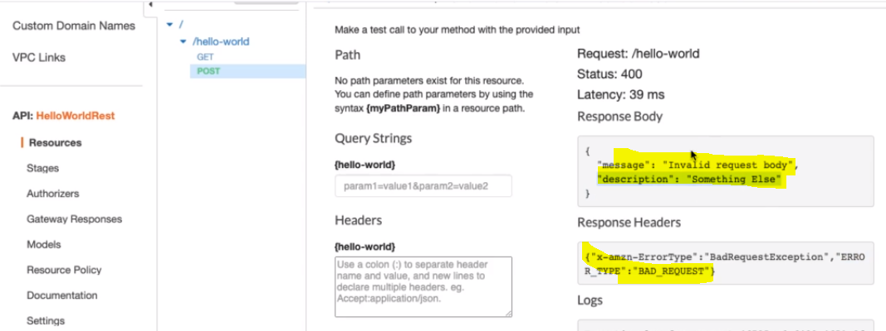

So here we are getting the customized Response Body and Response Headers.

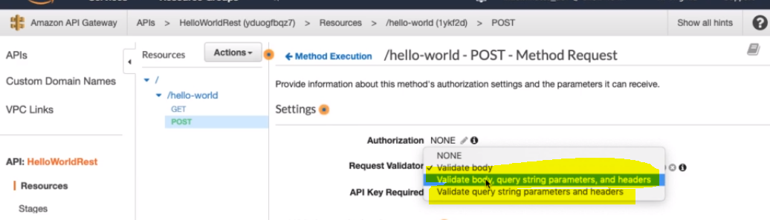

Let’s make the query string parameter mandatory

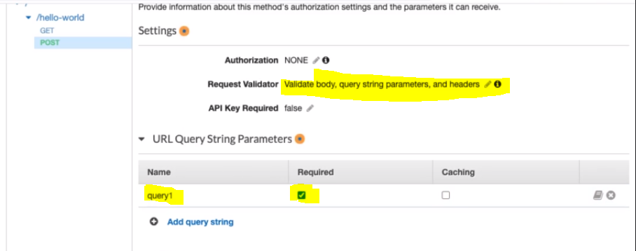

Now if we don’t provide the query string then we will get below message.

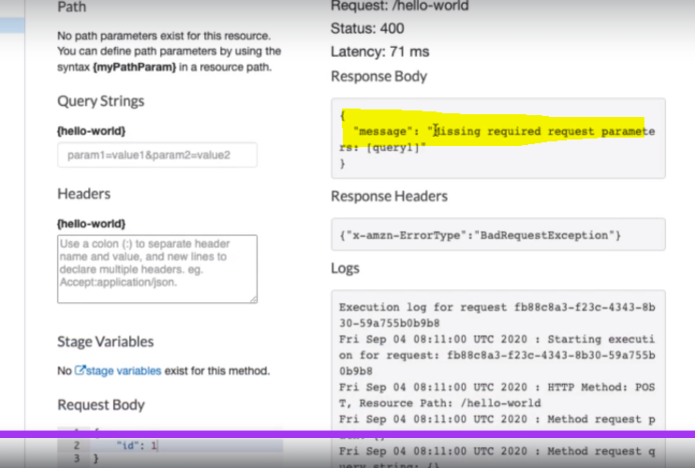

So now let’s pass the query parameter

|  |  |
| --- | --- |
|  |  |

So now request succeeds.

**93. Step 11 - Deploying API Gateways - Creating a new Stage**

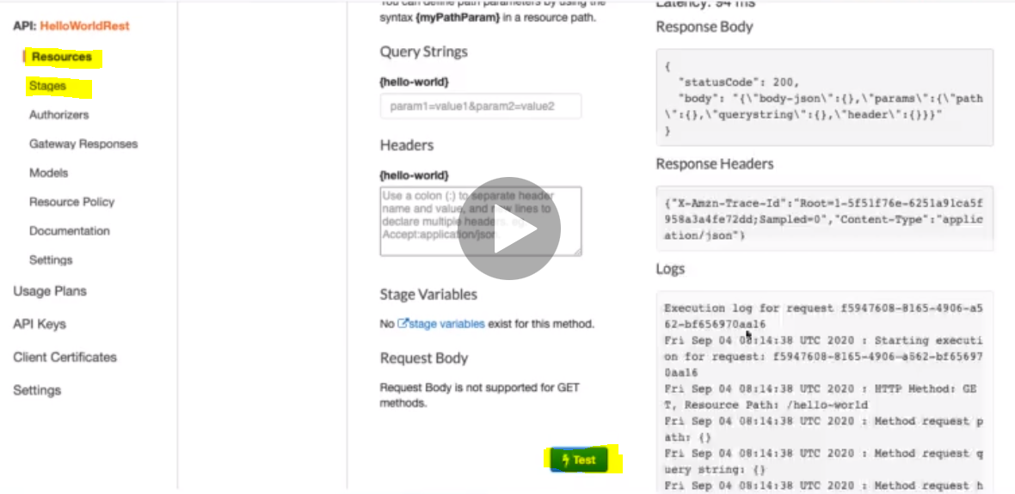

Until now we have been testing API Gateway by using the [Test] button available in the Method Execution to invoke our Lambda function.

Now let’s deploy this, and get a URL and using that URL will be able testing without using [Test] button. To deploy API Gateways we will be using Stages available under API and below Resources in the LHS menu bar.

Go to Actions > Click on “Deploy API”

|  |  |
| --- | --- |
|  | Choose a New Stage: Which will take us to create new stage. |

|  |  |
| --- | --- |
| Here we have provided stage name – dev and click on “Create” to create new stage |  |

So finally we have got our new stage with the name of “dev” along with invoke UR:

Now if we expand the dev then we will get invoke URL for “Get” & “POST” method because here in this Gateway API we have created two Method.

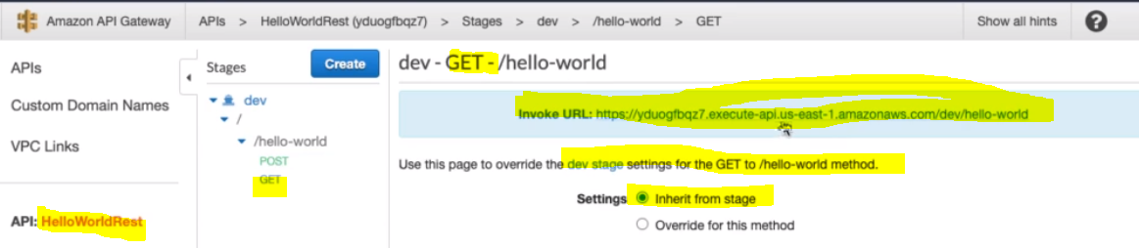

So here we have got the invoke URL for Get method for hello-world gateway API

If we click on this URL then we will get the response.

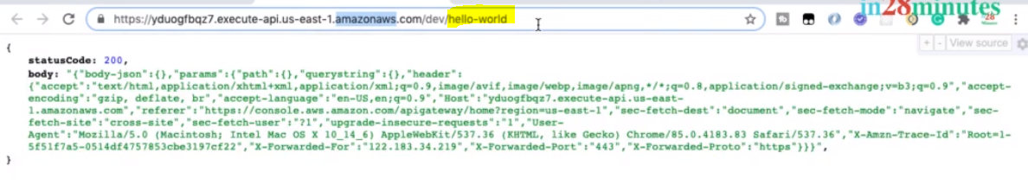

Using Rest client:

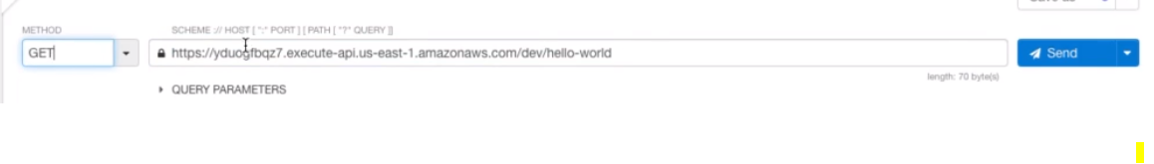

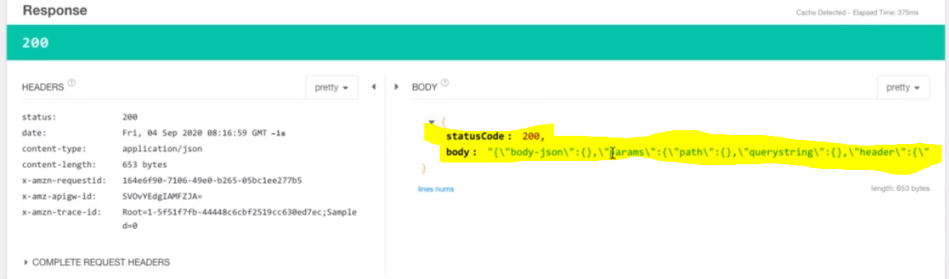

**For POST Request:**

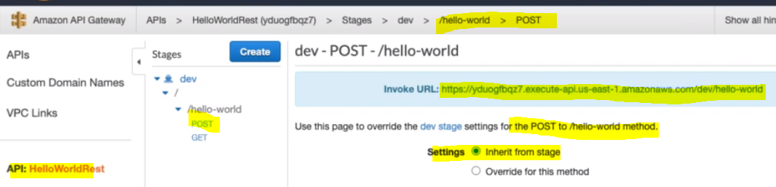

Since in the post Request we used to send the request body, and for testing POST request we need Rest Client so we can use any of the Rest Client like Postman where we can put this invoke URL, request body, Content type.

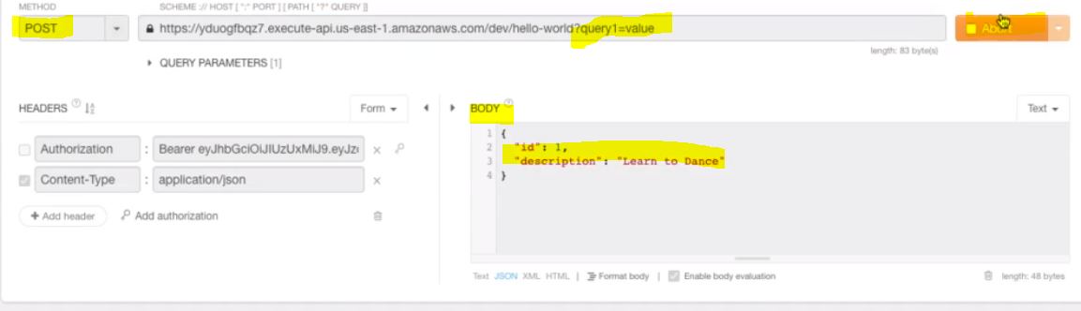

**Here we sending request body and query string in the URL and click on send:**

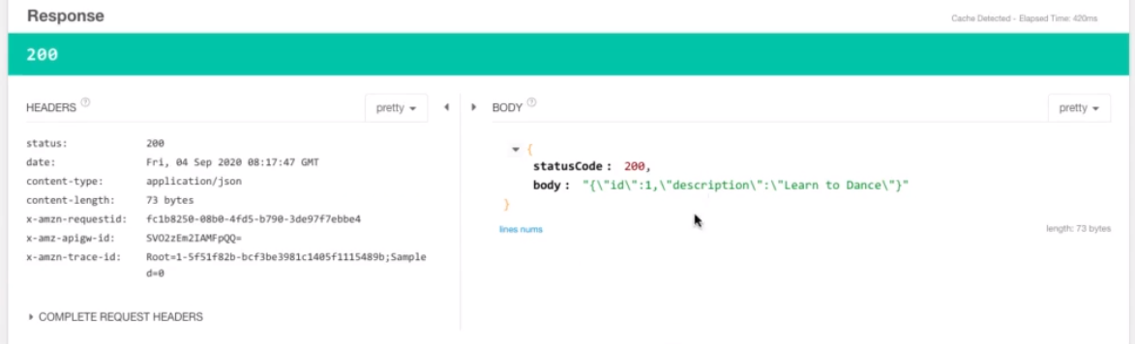

**And finally we have got the response from Lambda function using invokes URL:**

**So in this way we can deploy API gateway and test it from the rest client very easily.**

**94. Step 12 - Understanding AWS REST API Gateway Integrations - Custom vs Proxy Integration:**

So far we have discussed the below points:

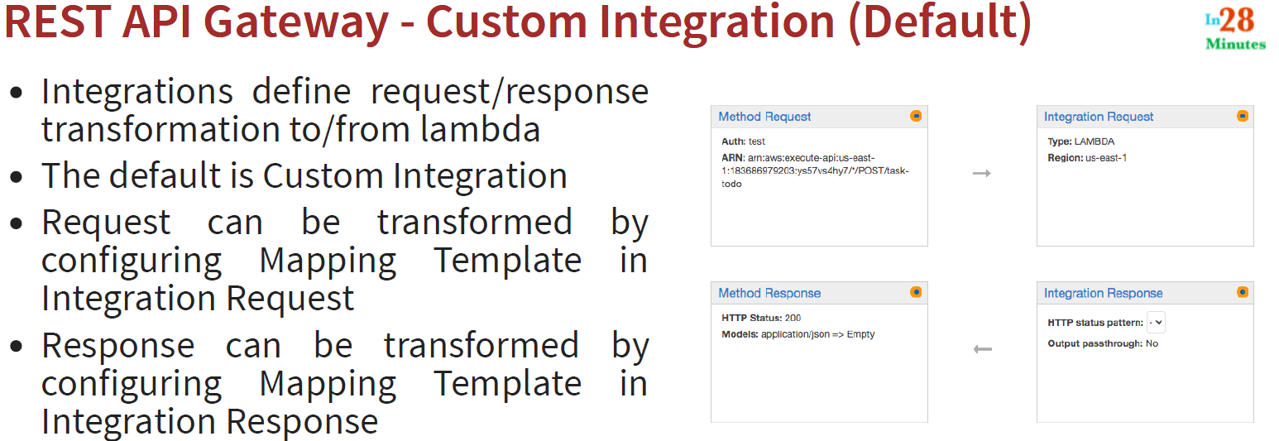

So this is about custom integration: Now let’s talk about Proxy Integration:

So apart from custom integration we can also configure **Proxy integration**:

So if go inside [Integration Request] box then we can enable proxy request here. And the thing that we can note that, we cannot customize the integration request and integration response. Then question arises:

**How we can integrate Request & Response in Proxy integration? And what happens if the API gateway defines a standards transformation for us?**

Ans: So in case of Proxy integration the API gateway defines standard transformations for request and response.

|  |  |
| --- | --- |
|  | So if we give the LHS request with the body { message: welcome} to the API Gateway then the in case of Proxy integration we don’t need to do any transformation inside the Integration Request and Response. |

**By default API gateway transform the request and convert into below format.**

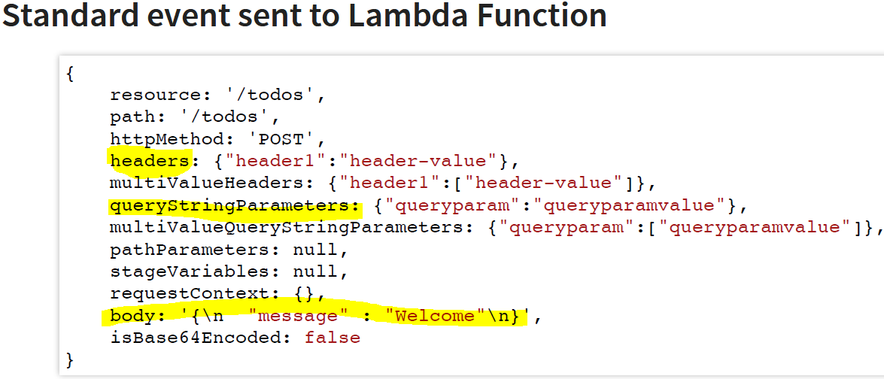

So what all we send as a part of body request it gets transformed to corresponding body request of event. So at the Lambda function side we can access lambda body request using [event.body]. Similarly whatever headers we are sending as request from the API Gateway, it is also becomes the part of event of lambda function. And the queryString gets transformed to queryStringParameters in the lambda function event.

This automatic transformation of the request is done by API Gateway when we are using API Gateway Proxy Integration.

Similarly, same transformation is happens for the response also:

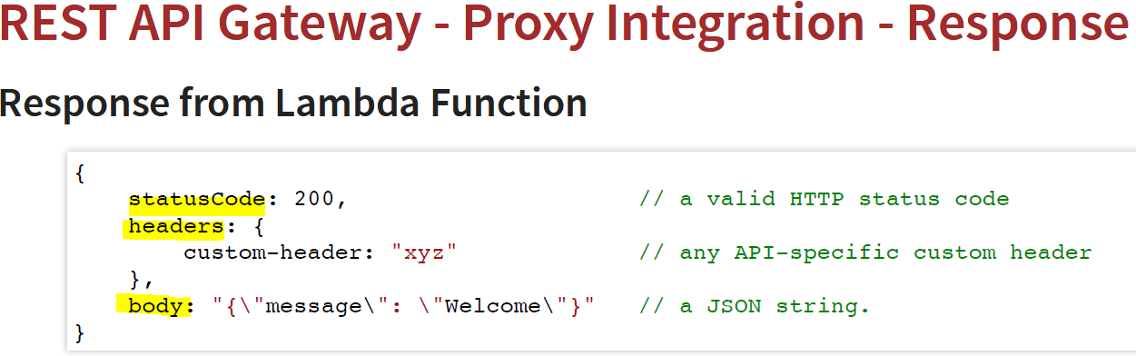

So once we get the response from the lambda function in the above format then the corresponding response transformation done by API Gateway is given below.

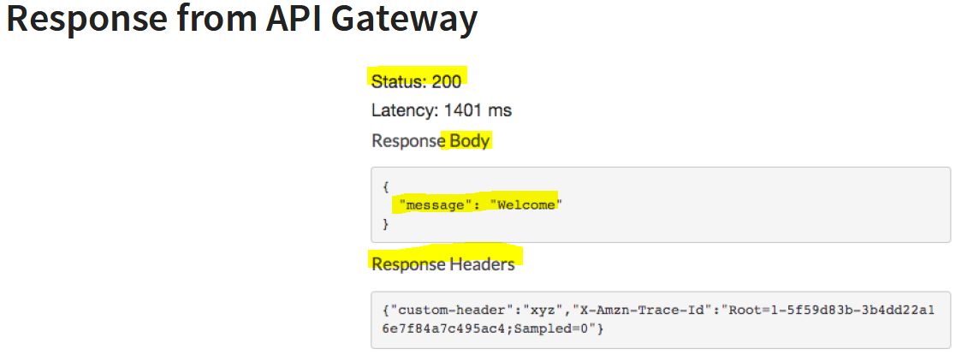

So whatever present in the body of lambda function response, it will become the part of Response Body at the API Gateway and whatever we put in the statusCode at the lambda function response, it becomes Status at the API Gateway side. And same for headers also.

The important thing is that when we use Proxy integration then we don’t need to do any transformation of Request and Response. Everything related to request (like headers, body, query String) are passed to lambda function in a proper structure and same thing in case of Response. API Gateway will take care all the things to place all the request and response in the right place in a pre-defined structure.

**95. Step 13 - Exploring REST API Gateway Lambda Proxy Integration**

So far in the previous steps.

1. We have created Lambda function
2. Invoked the lambda function through the API Gateway
3. Deployed the API Gateway in the Dev Stage and run from invoke URL

For the proxy integration let’s create new resources and new method to show demo.

|  |
| --- |
|  |
|  |
| So we have created the resource and now let’s create Method from Actions: |

Now once GET method gets created: Click on the Get link to enable Proxy integration:

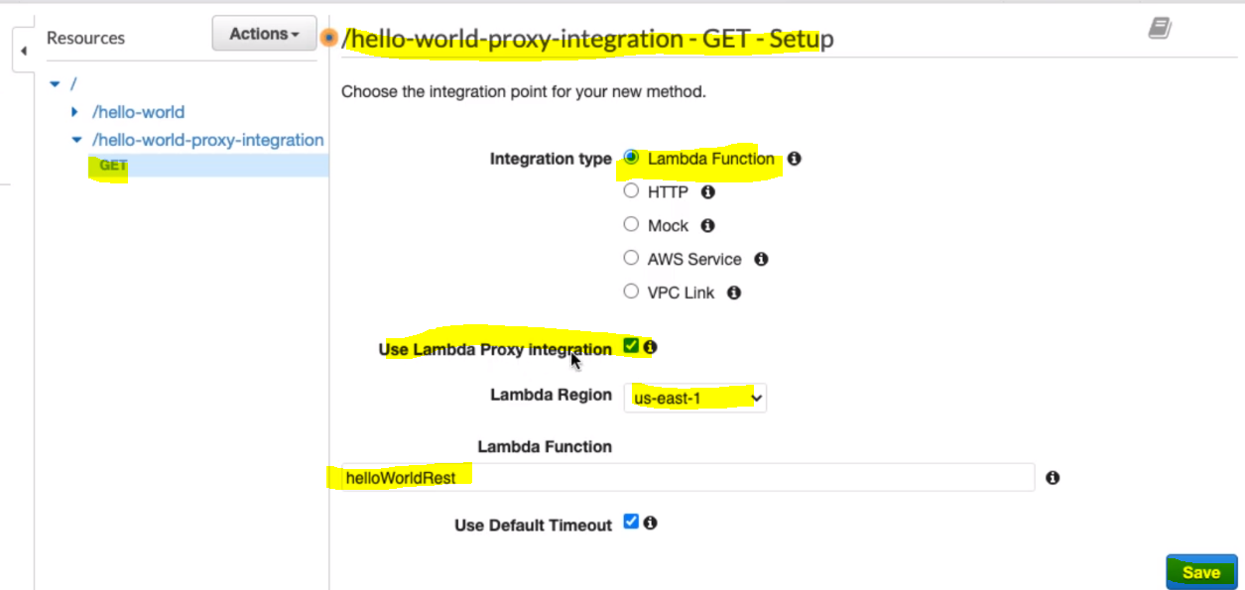

1. We have taken integration type : lambda function to be invoked
2. We have taken the same lambda function [helloWorldRest] which we have used in earlier steps
3. Select the Region where the Lambda function is created and available
4. And finally check the checkbox to enable or use Lambda Proxy Integration and save

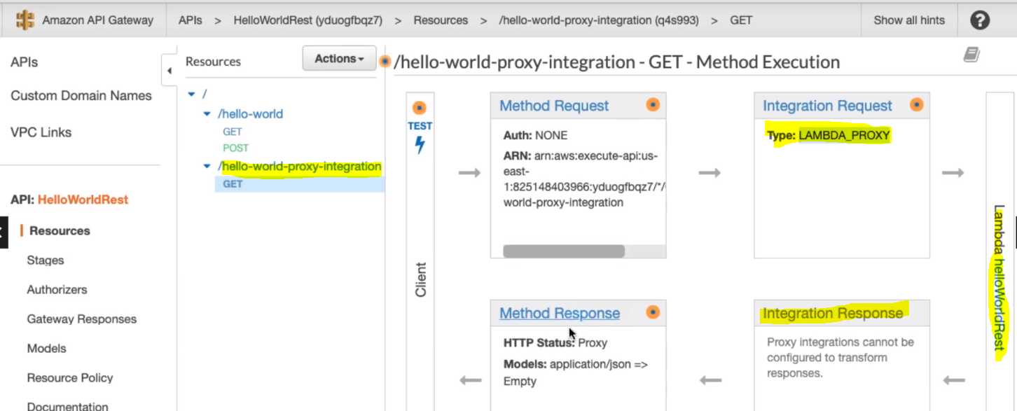

Here we can see that we have Integration Request type: Lambda Proxy and we can do any transformation in Req/Res

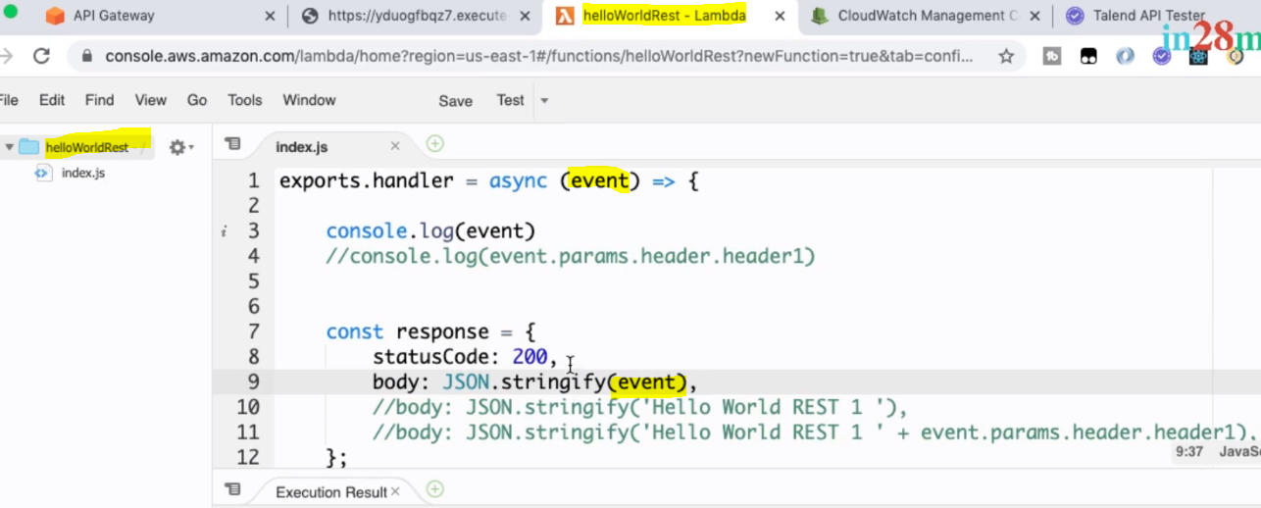

Here in the lambda function we are stringify event.

Now let’s Test this proxy integration from the Method execution:

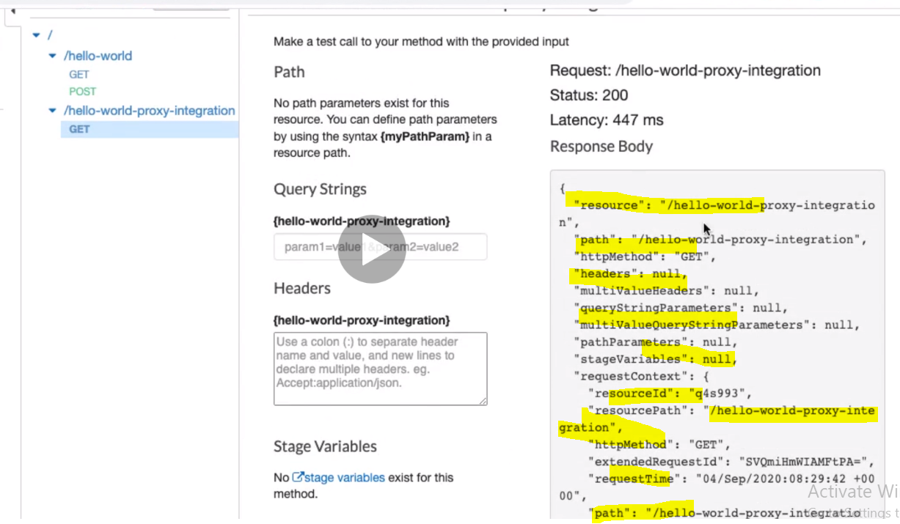

So here we can see that in Response Body we have got everything because if we see in the lambda function we are stringify the complete event.

Now let’s make some changes in the lambda function and test again.

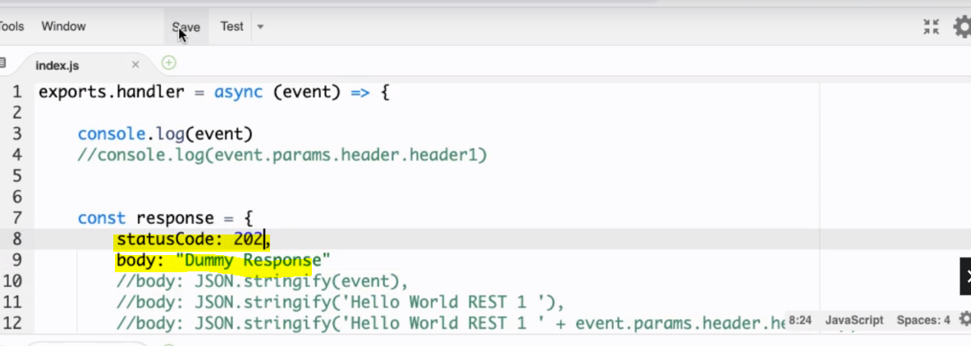

Now let’s go and test again:

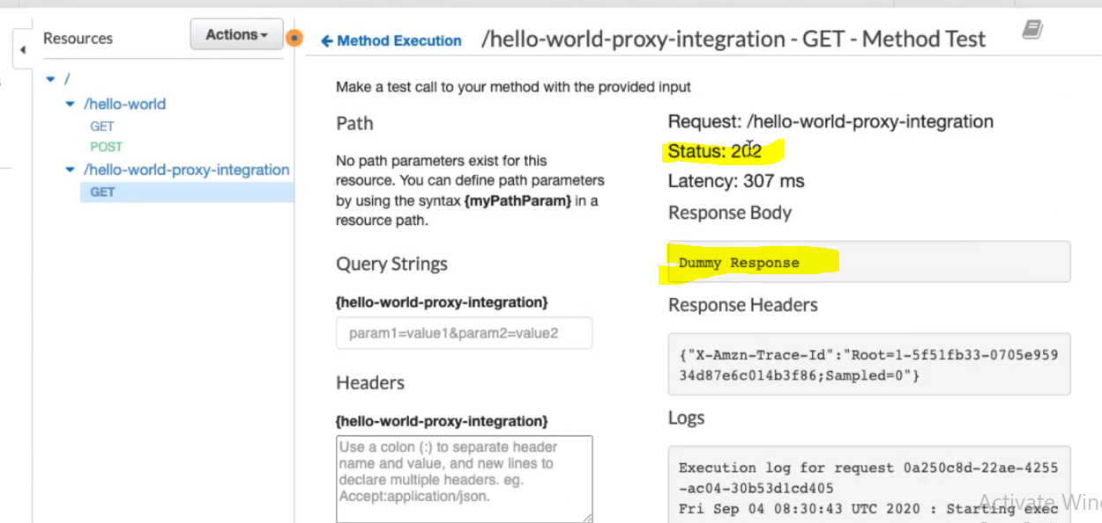

Now if we see then Response Body contains only the body defined in the Lambda function and getting the same statusCode in the status. So here API Gateway takes care automatically to place all the response accordingly from the structure defined in the Lambda function.

Note: If any error found the lambda function defined structure then we would not get response at the API Gateway side also:

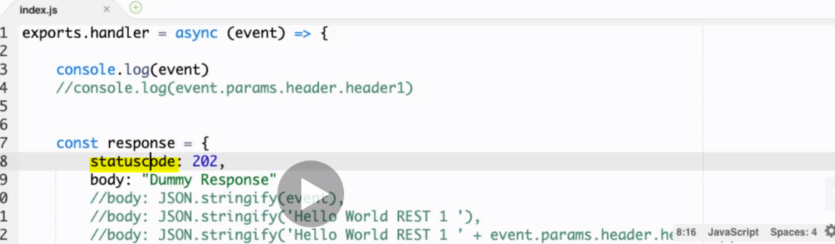

Here we have made a very small mistake : instead of capital C, we have ketp small c in the statuscode. Now let’s test again and check.

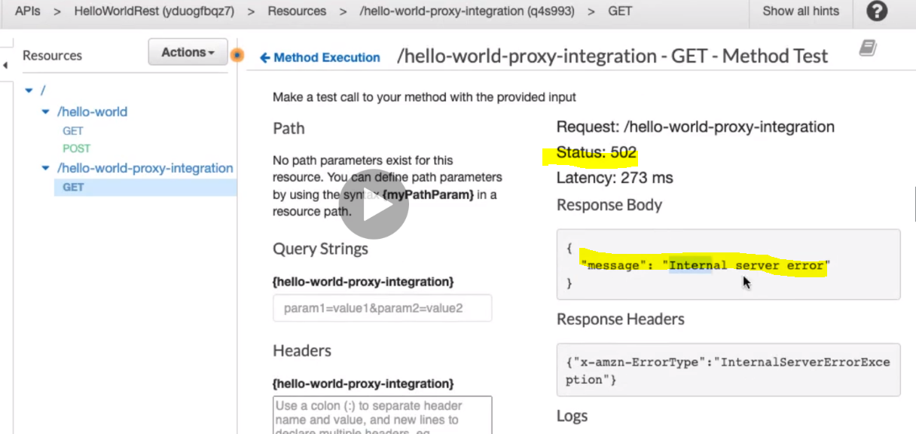

As here we can see that we are not getting correct status and Response Body.

And if we see in the log then we will get proper reason:

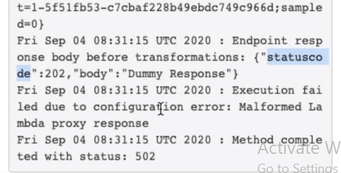

So here it is saying that there is modification or transformation in the lambda proxy response, which is not suppose to do.

Note: One more important thing is to note that the Query String and Header are also passed to lambda function by default. How they are passed?

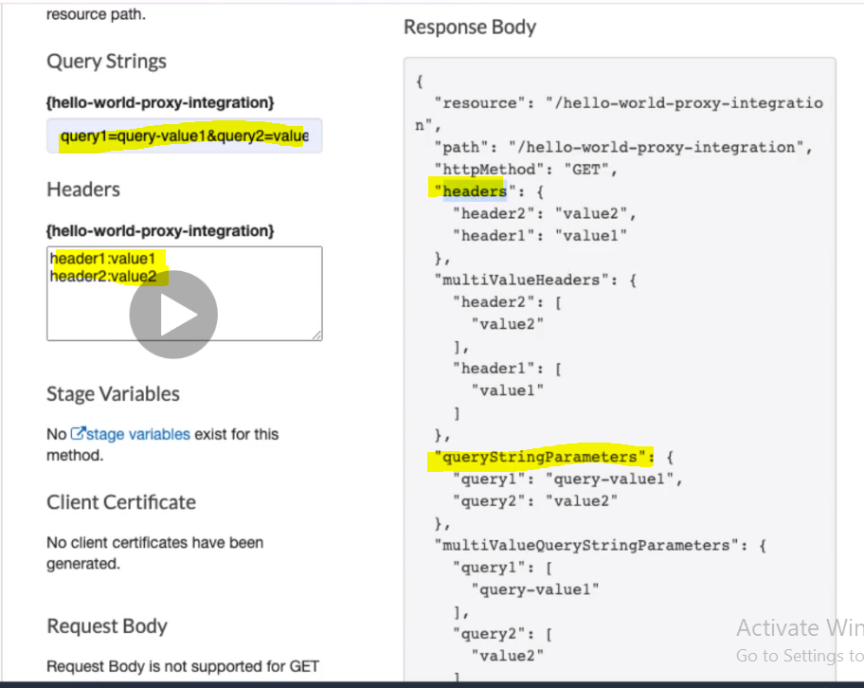

And here we can see that what all the QS and Header we have passed to Lambda function, it automatically structured in the API Gateway response.

Note: So we have understood that Lambda function and API Gateway communicates with each other and transforms there request and response automatically in case of proxy integration. The important thing to note is while creating lambda function, we have to follow he pre-defined structure inside the lambda function, otherwise API Gateway would not be able to understand and in result we would not get correct response at API Gateway.

**96. Step 14 - Implementing Rate Limiting and API Keys using AWS API Gateway**

Click on Usage Plan available just right below to API Gateway.

Click on Create Button To create Usage Plan:

The Usage plan Help to measure API Usage. With the usage plan, we can configure Throttling and quota limit on each API Key.

1. Throttling limits define the maximum number of request per second available on each key. There are two parameter need to set as the part of Throttling. 1- Rate 2- Burst

**Rate:** It defines the number of request receiving per milisecond. So if we mention 1000 inside Rate box then it means one request per MS. So for all 1000 request time is 1000 MS. This is called Rate. But if we get any request more than a second then those requests will be throttle.

**Burst:** it defines how many request we can get a particular milisecond. Let’s say we have defined 100 requests as Burst request and all of sudden 500 requests come at the same time at the same milisecond. So Burst request ensure that only 100 requests will be process and remaining 400 requests will be throttle.

1. Quota limits define the number of requests each API key is allowed to make over a period. This is used for longer duration. It defines the number request to be processed per day or per week or per month.

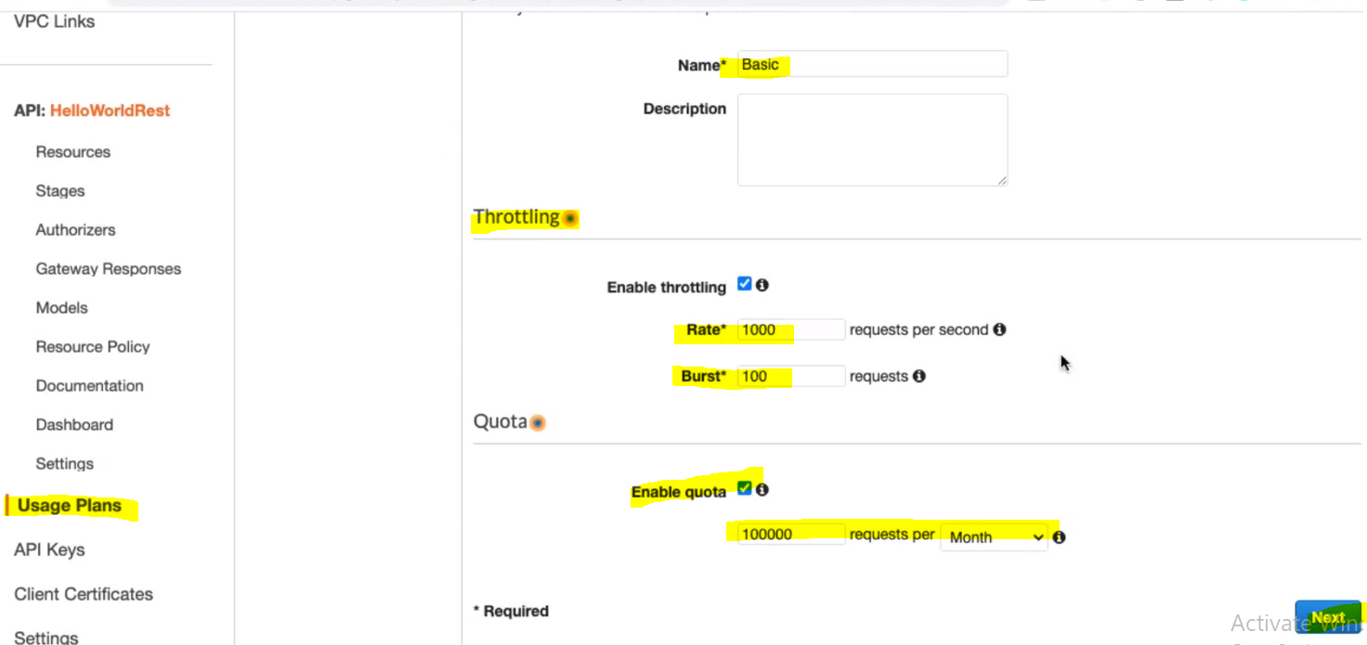

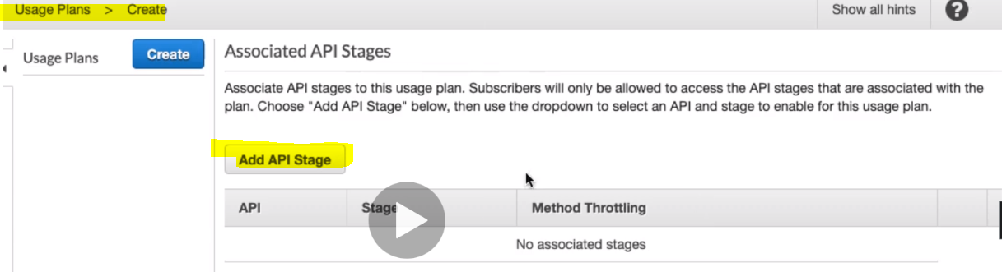

Click Add API Stage: As we have already created the dev stage for API so let’s add here the same.

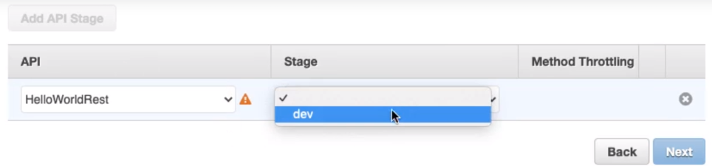

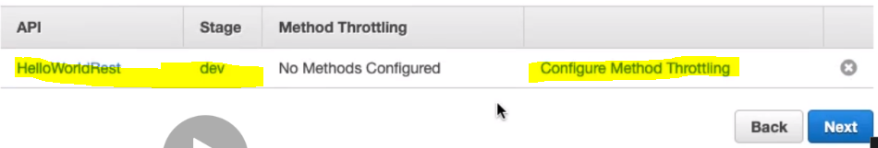

We can configure the Throttling at the Method level.

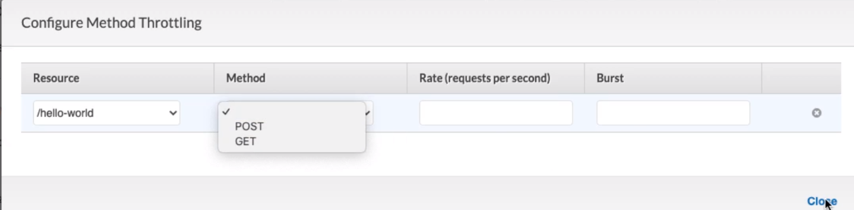

But let’s not configure the throttling at method level.

**So now we have created the Uses plan and now let’s associate this plan with API Key so that consumer can use this key to consume API.**

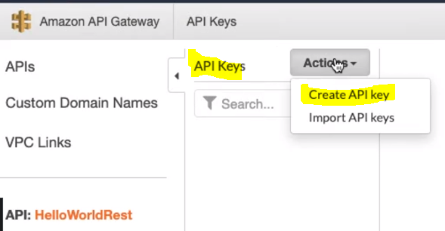

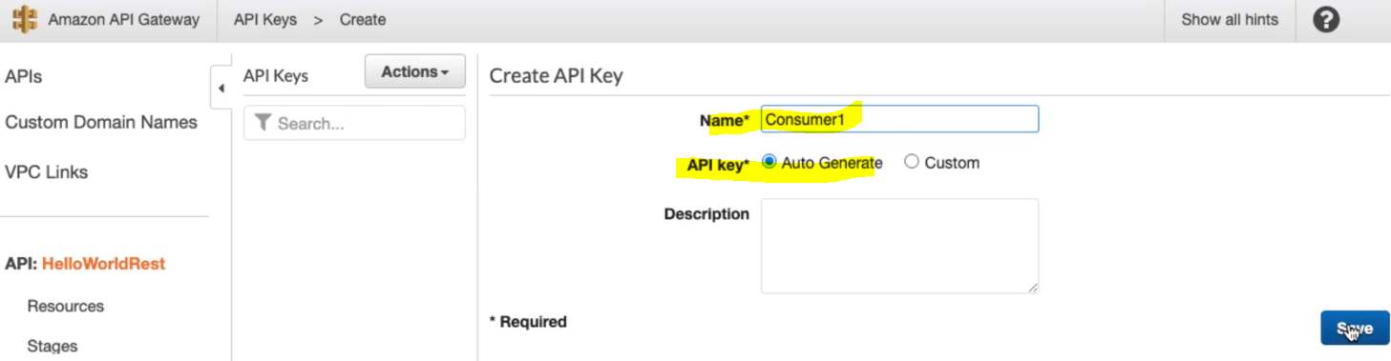

Select Auto Generate API Key.

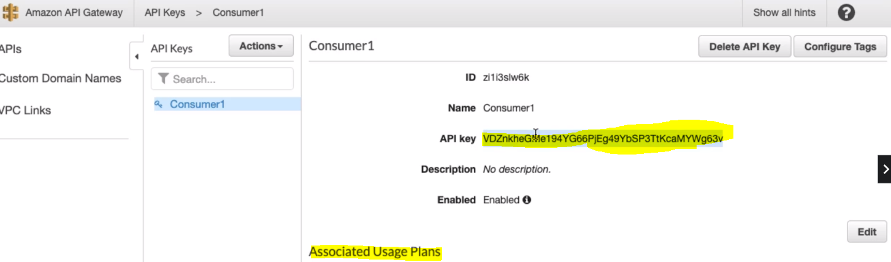

Now let’s associate the Consumer API Key with Usage Plans below. Copy this API Key.

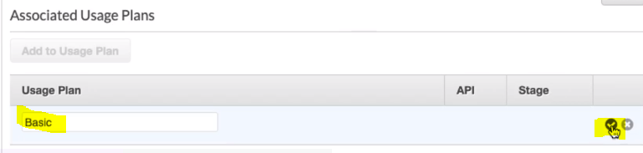

Since above we have already associate the API with usage plan, so once we give the Usage Plan name and click on tick mark, it will automatically retrieve the API name and its stage where the API is deployed.

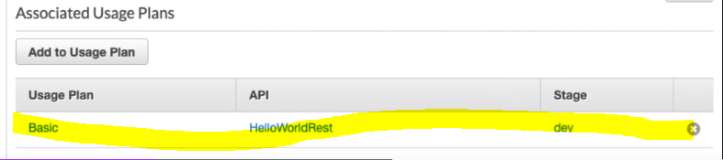

So now we have Created API Gateway > deployed it in dev stage > Configure the Usage Plan > Created API Key and associate the Usage plan against the API Key.

Now let’s use this key as an authentication to invoke the API Gate way.

Let’s go back the API Gateway.

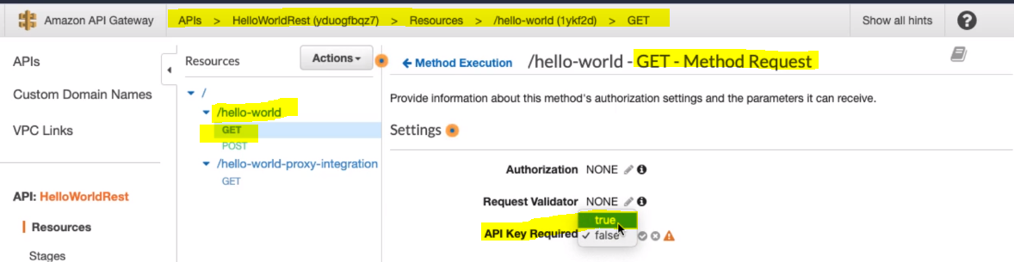As here to enable and use the API Key as an authentication we have to make it mandatory by selecting its **true** value.

Note: Since we have make changes in the API Resource so we would have to deploy it once again in the “dev” stage to reflect latest changes.

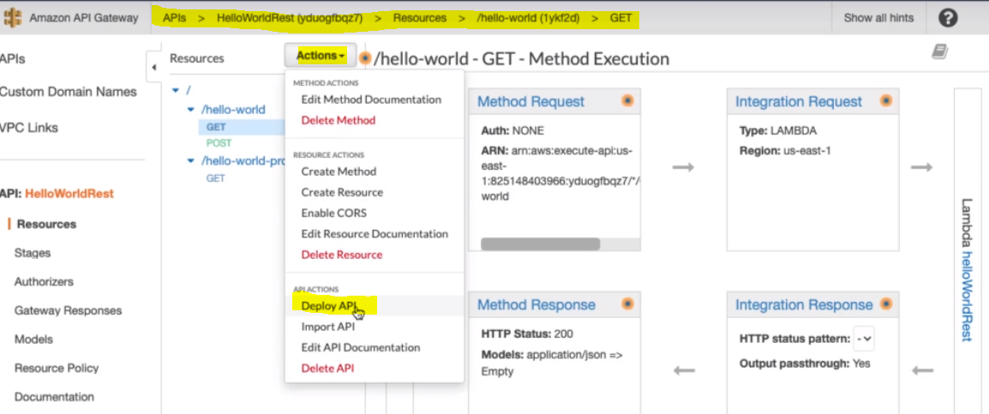

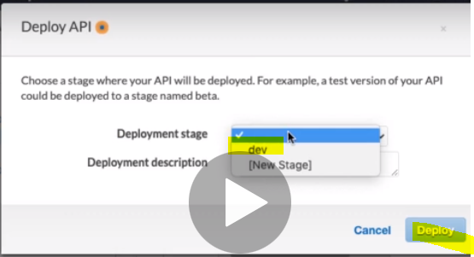

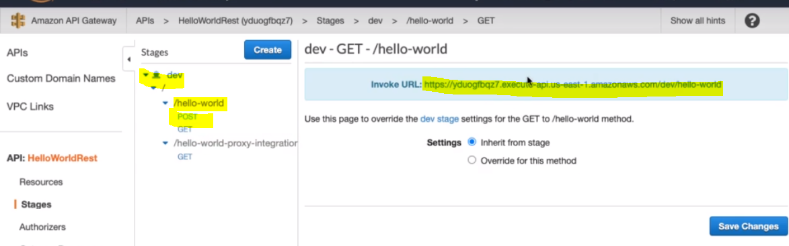

Now let’s go to hello-world resource Post method: take its invoke URL and execute it with the help of Rest Client.

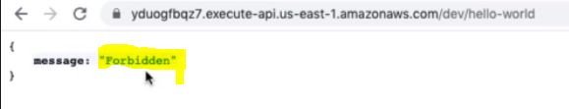

And we are not getting correct response, instead we are getting Forbidden: Reason -> we have enabled API Key Required.

So to invoke the API we have to provide its API Key in the header section of rest client then only it will invoke the API.

We can copy API key from below screen

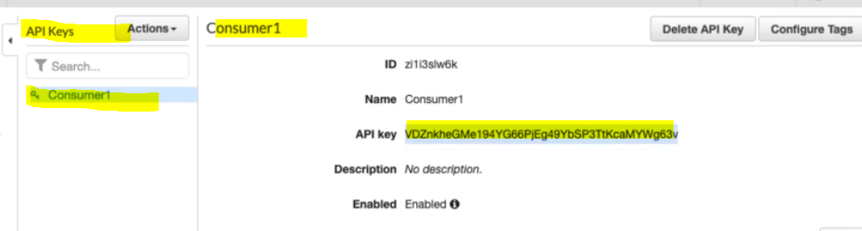

Let’s go to Rest client write the header for API Key- [X-API-Key] and provide its key value and click on send

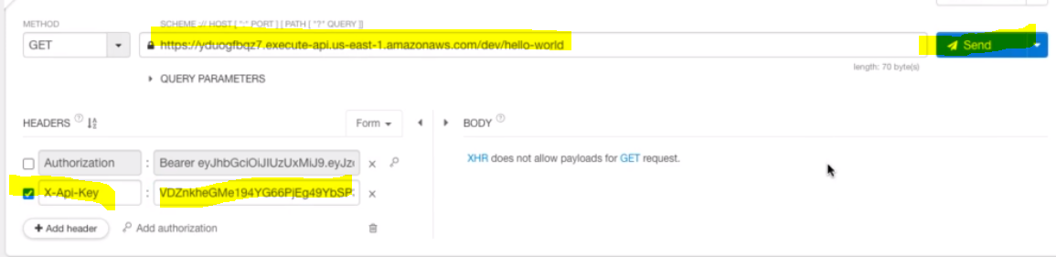

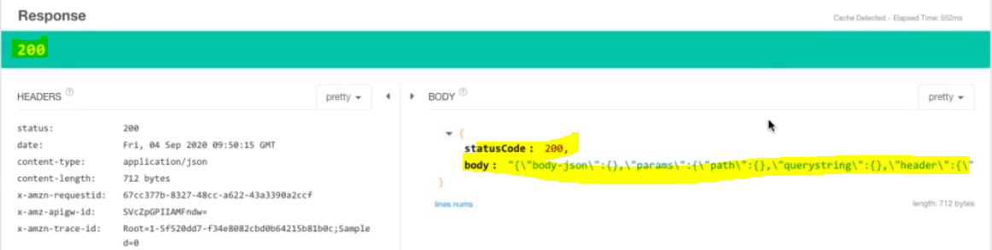

So now we have to 200 response because here we have passed correct API Key otherwise we will get forbidden.

In this specific step we have done the following things.

1. Created a usage plan and associated it with consumer
2. Consumer now would have specific limit configured in the usage plan
3. Consumer will have one API Key and whenever consumer wants to access API resources every time we have to pass this API key in the header part with the request.

**97. Step 15 - Exploring AWS API Gateway Stages**

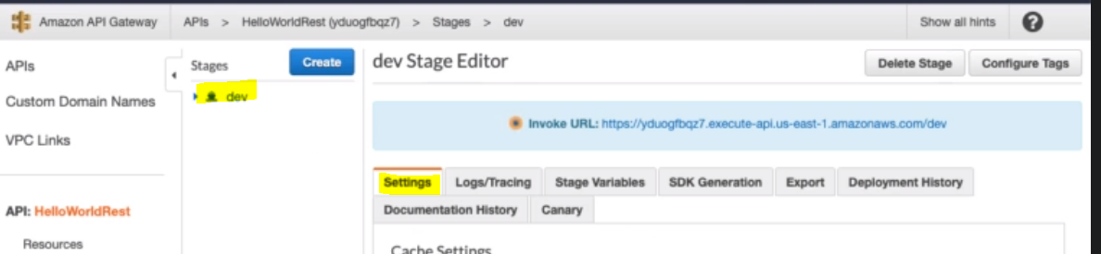

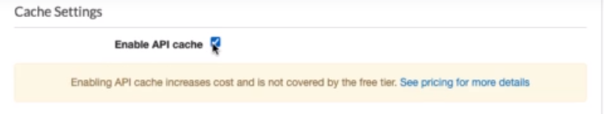

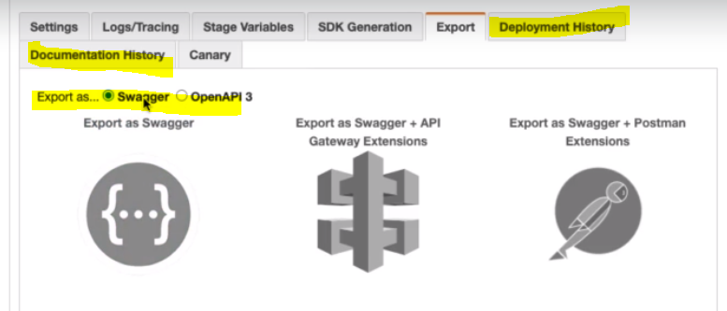

So in the stage we can do the following things.

1. Can enable the cashing and caching size
2. Trace the log
3. Export it for different uses
4. Check the deployment history

**98. Step 16 - Getting Started with AWS API Gateway - HTTP API**

**So far we have learnt about REST API and got the below points related to REST API.**

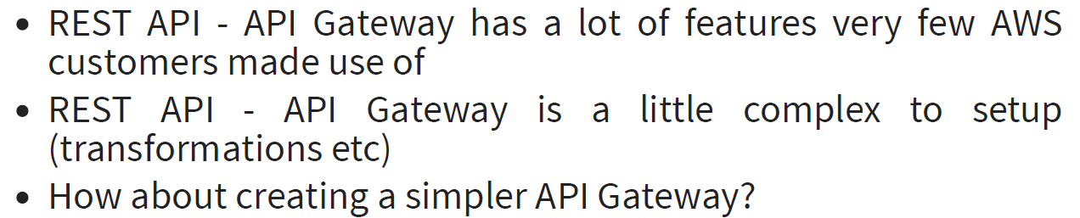

**Answer**: To create the simpler API Gateway: AWS has given another approach create API: which is nothing but HTTP API. The Naming is confusing but this is ->

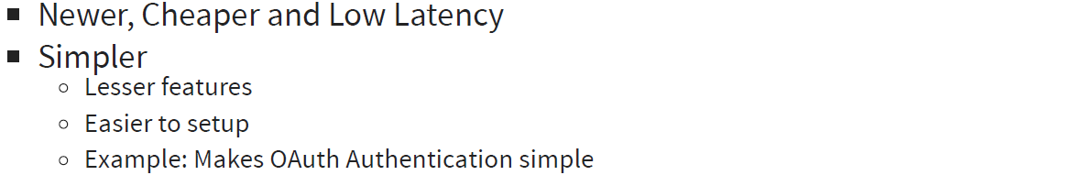

Note: Before starting HTTP API we have to understand one important concept. Payload version.

When we are making version of HTTP API – API Gateway, there were two versions of payload which are supported it’s called 1.0 & 2.0.

Recommendation from AWS is that use 1.0 if you are migrating from existing implementation of REST API proxy transformation. And it is recommended to 2.0 for newer API.

Q: Now Question arises what is difference between 1.0 & 2.0.

A: So the answer is:

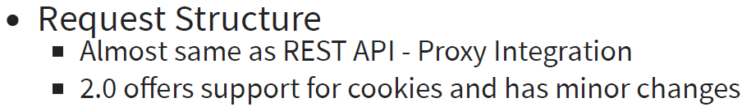

**Request Structure**

So as far as request structure goes, request from user comes to the API Gateway and API Gateway performs the transformations of the request before it goes to the lambda, so as for as the request structures is concerned there is no difference of request structure which goes to the lambda function between 10. And 2.0 versions.

The only minor difference is that 2.0 offer supports for cookies and few minor changes.

Note: Even for the HTTP API when we send request to lambda function then API Gateway transforms those request exactly similar to REST API.

i.e.

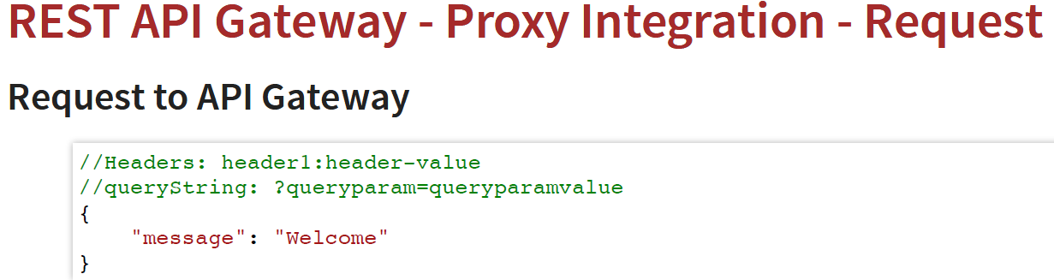

The above structure is for 1.0. For 2.0 versions there is minor change in the standard event or request which is sent to lambda function. And which is nothing but the cookies which sent added as extra to make 2.0 version request.

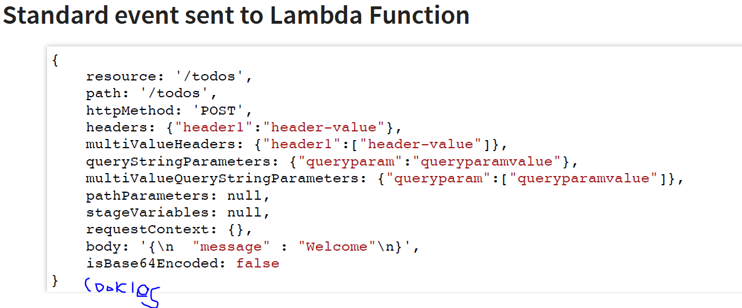

**Response Structure:**

So when we return response back from the Lambda function then API Gateway would transform it before sending to the consumer. So as for as response is concerned the response is also similar to REST API – Proxy integration i.e. if we lambda function return the response structure with (statusCode, body, headers) then it is supported.

But in additions to above 2.0 supports a simple structure also i.e. we can return the valid JSON response containing only body of the response. So if just send the body as response then in 2.0 version statusCode is automatically added as 200 in the response.

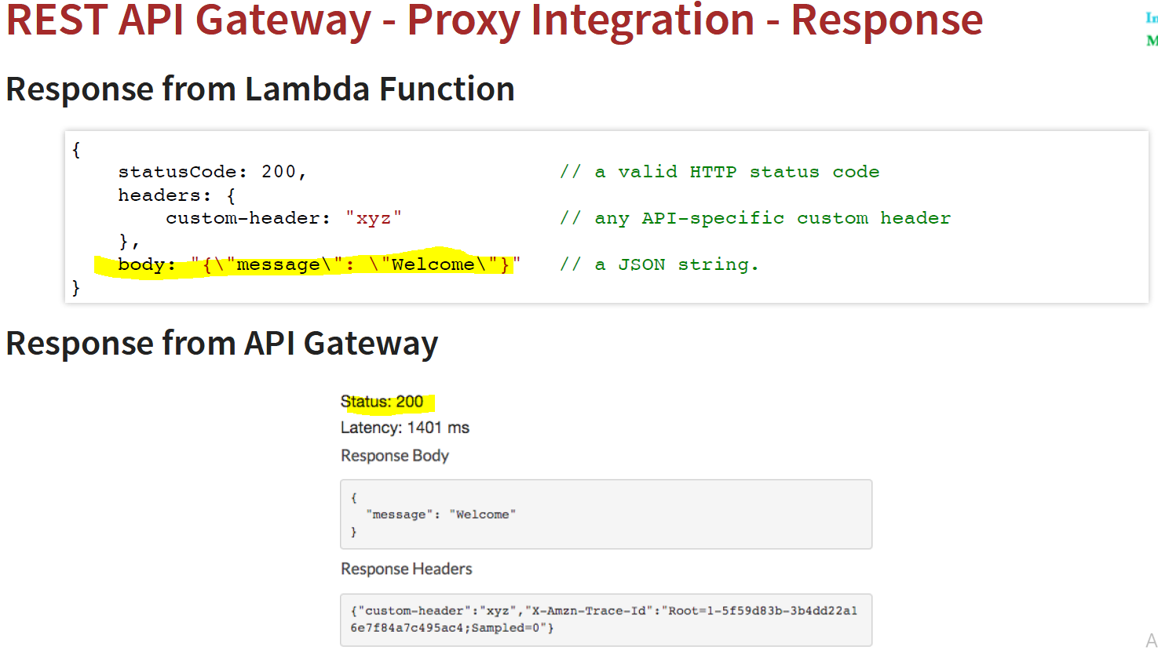So here the above response works perfect for 1.0 as well as 2.0 but in 2.0 we can send response with the body only i.e. don’t need to include statusCode : 200 & Headers. And status 200 will be included automatically from the API Gate ways response side.

In short:

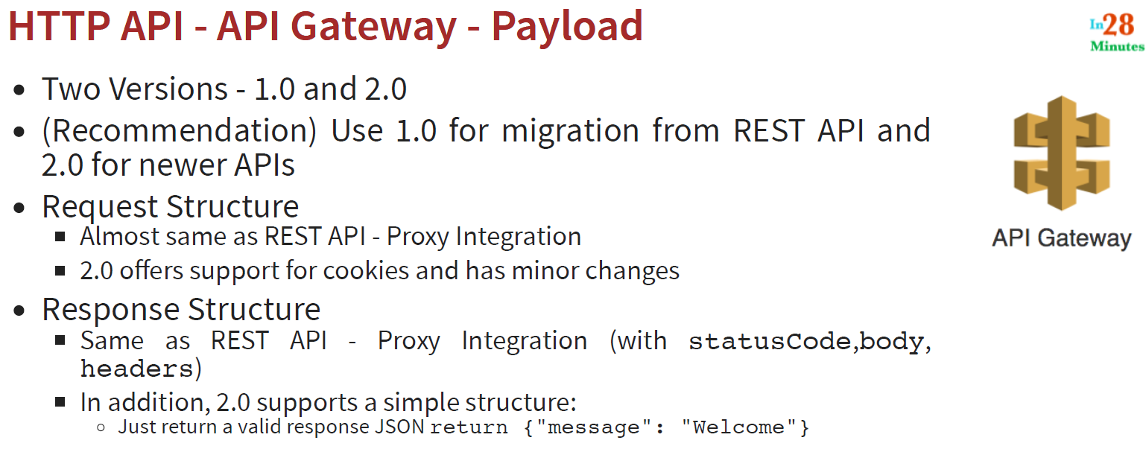

**99. Step 17 - Creating HTTP API - AWS API Gateway**

So far we have been playing the REST API. Now let’s play with HTTP API.

1. Let’s create new lambda function

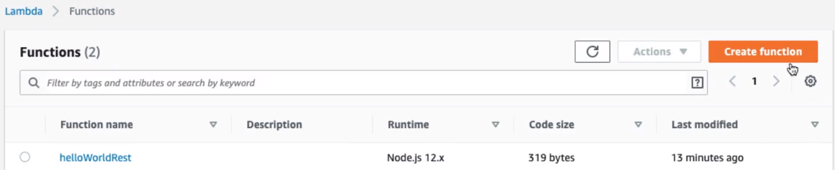

Here we can see the helloWorldRest that we had created in the earlier step for REST API. Now let’s create new lambda function for HTTP API. Click on “Create function”

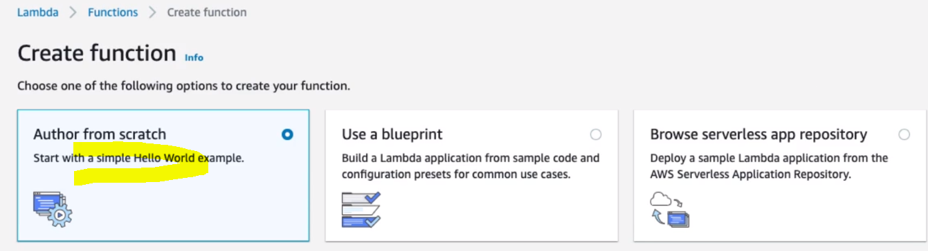

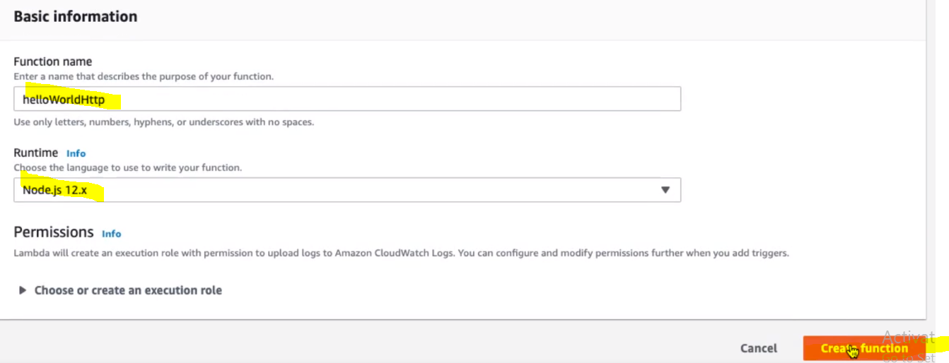

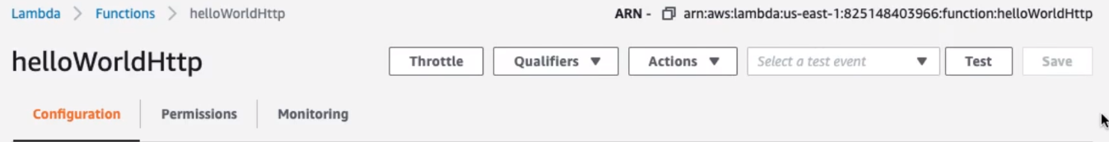

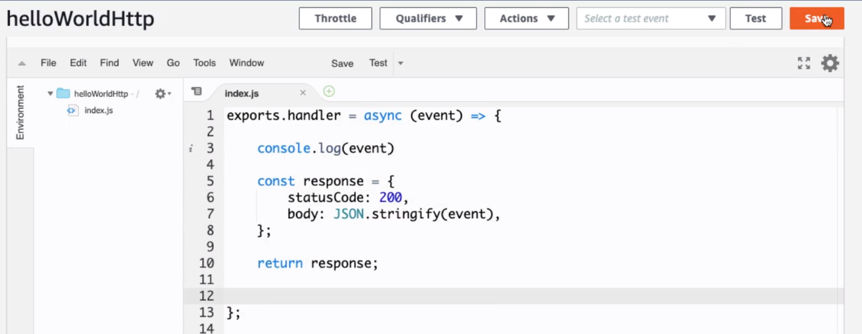

Click to save: Now we have helloWorldHttp lambda function ready to integrate with HTTP API

1. Let’s create HTTP API from scratch: Click on Create API Button.

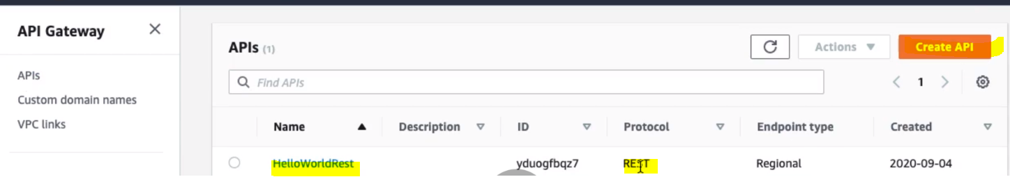

|  |  |
| --- | --- |
|  | This we have already created in previous steps |

Let’s click on Build of HTTP API to create HTTP API

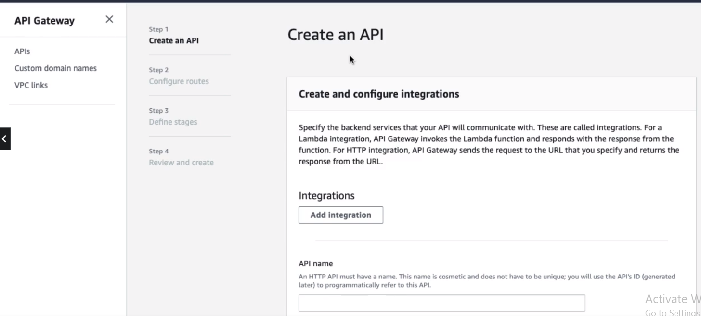

As we can see that Creating HTTP API involves four steps.

Step1- Here will integrate Lambda function by clicking “Add Integration”

Provide the following detail in the below screen

1. Select the integration {Lambda}
2. Select Region
3. Search the lambda function that we have created above
4. Select its payload version
5. Provide the HTTP API Name
6. Click Next

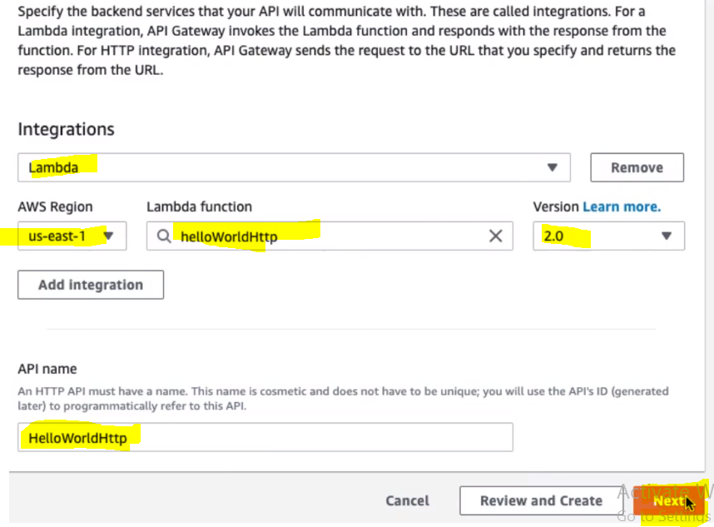

Once we click next: it will take us to the next step to configure Routes:

**Step-2 : Configure Routes**

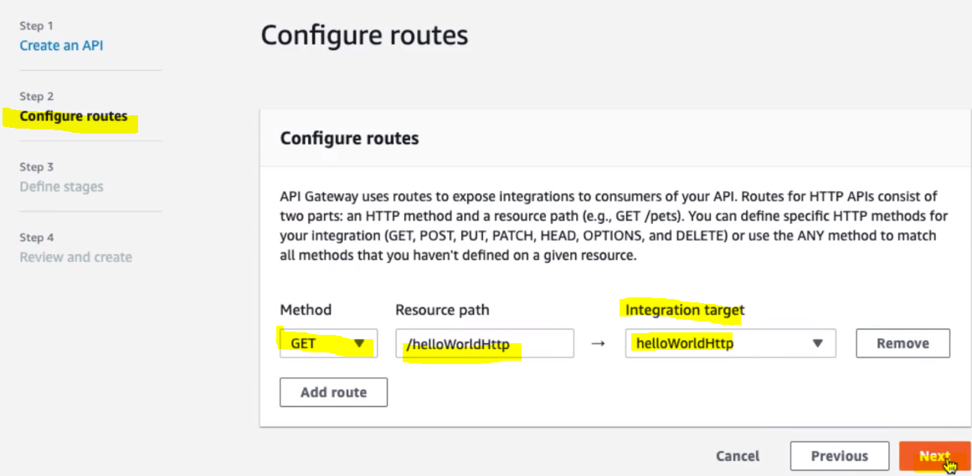

So basically in this step we configure the Method, Resource Path and Integration target (Lambda Function Name). Click Next:

**Step-3: Define Stage:**

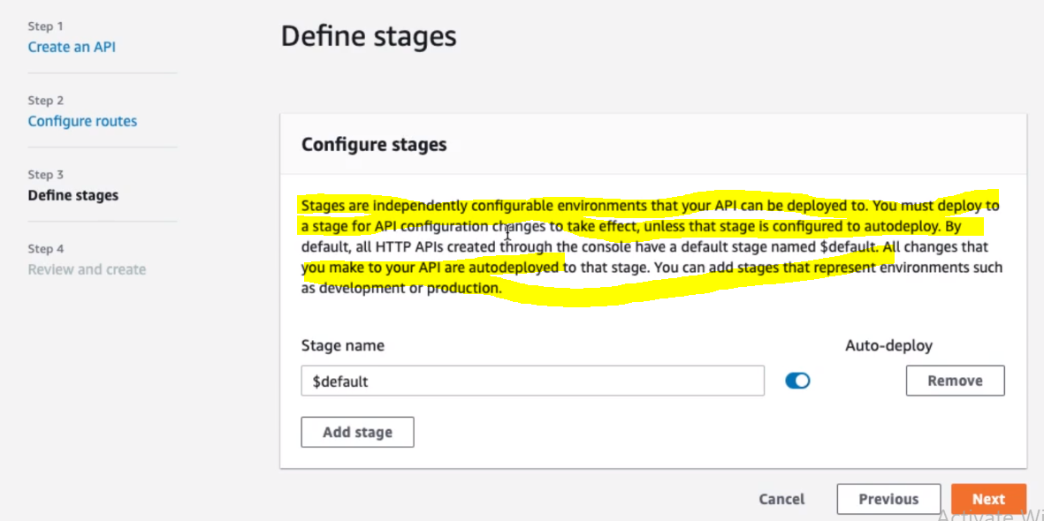

In the previous step (REST API) we had to deploy API Gateway manually to the stage.But here in case HTTP API, it is auto deployed to the stage.

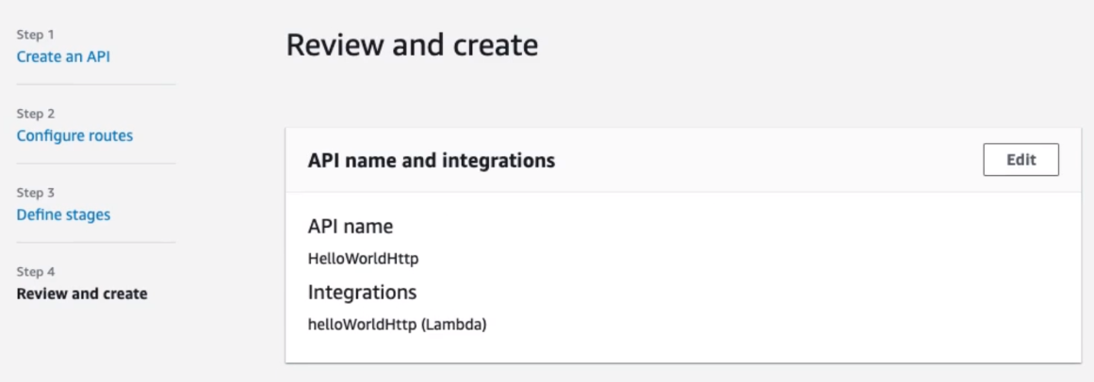 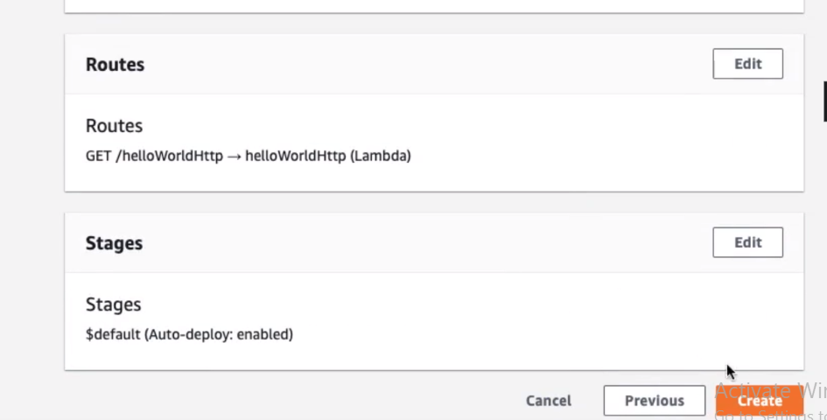

Finally review and Create the HTTP API:

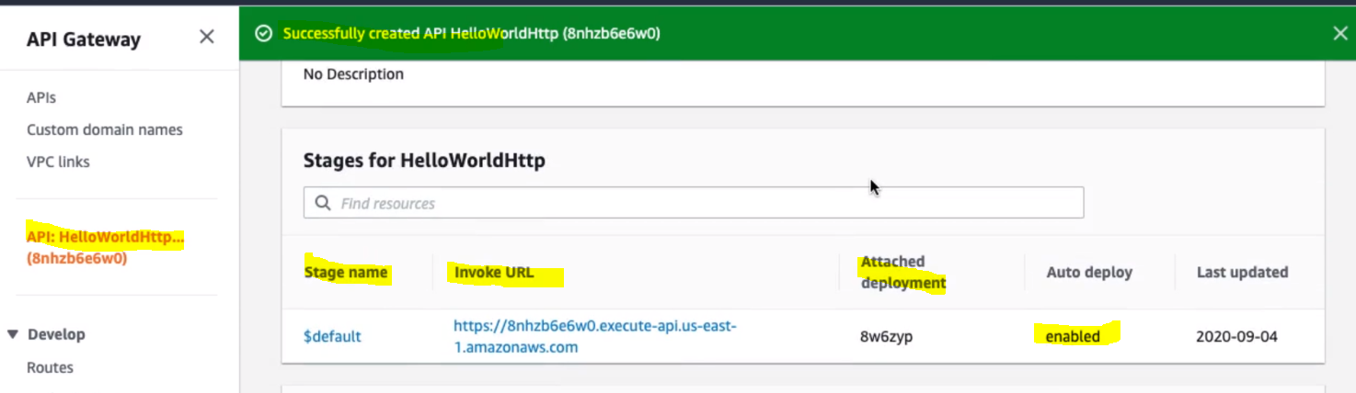

**So here we have got create our HTTP API with stage and invoke URL**

The HTTP API does not allow to test API directly. We can test HTTP API using its invoke URL. Let’s Click on the invoke URL

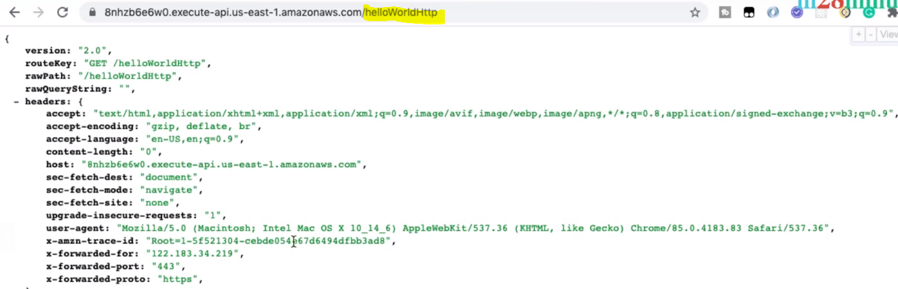

And hence we have got the response from the HTTP API Gateway.

**100. Step 18 - Exploring HTTP API - AWS API Gateway**

So in the previous step we have create API Gateway using HTTP API and we were able to invoke API Get method using its invoke URL and got the response as expected.

Now try to pass query string with the URL and after that let’s pass header using Rest Client.

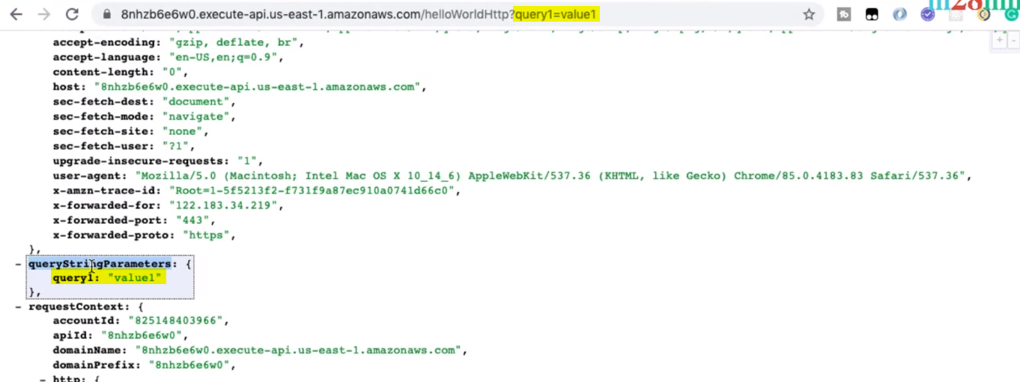

So we can see that query string got added in the response automatically in case of HTTP API, while in case of REST API, we have to manually set the query string in the Request then only we used to get the response.

Now let’s add headers:

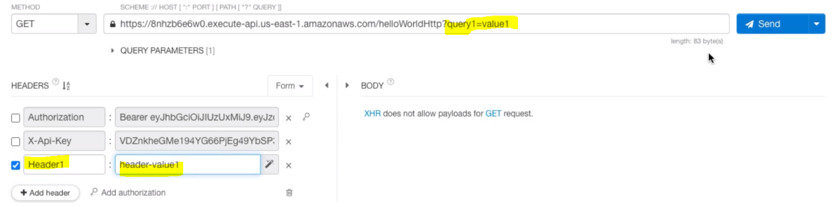 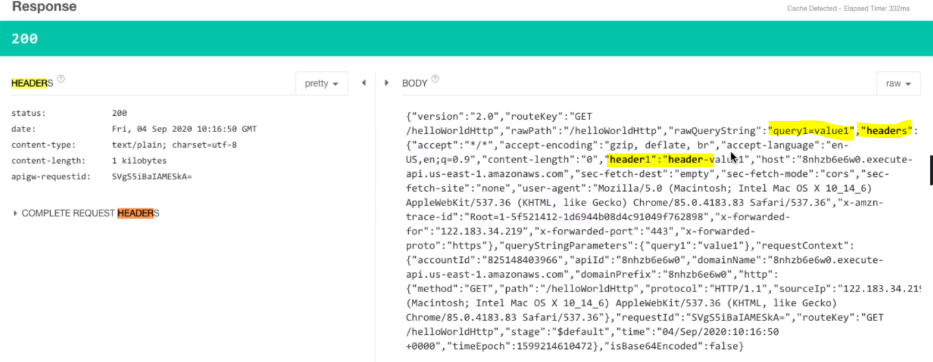

Note: Since here we are using version 2.0 so we don’t need to set the response as per the AWS format, just return the response in the lambda function and it will become automatically body and status of the API Gateway.

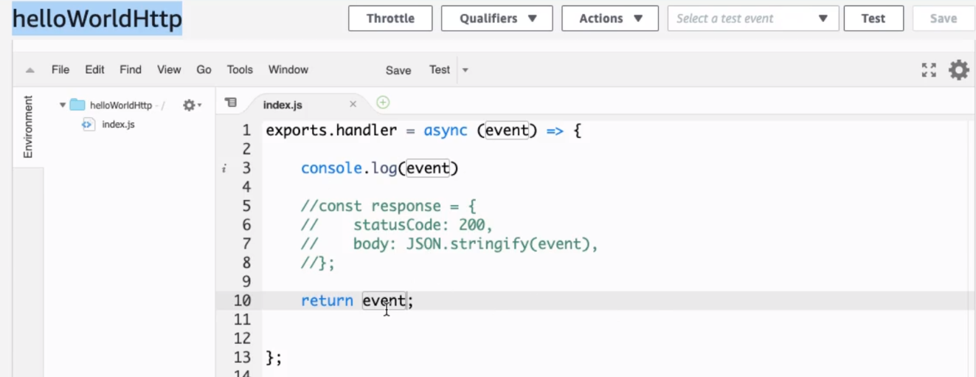

Here we are not formatting (or following the structure) response as per the AWS REST API, we are just returning the event. Now let’s save the change and test.



-----------------------

In short all the screen is given as: Test for Post Method:

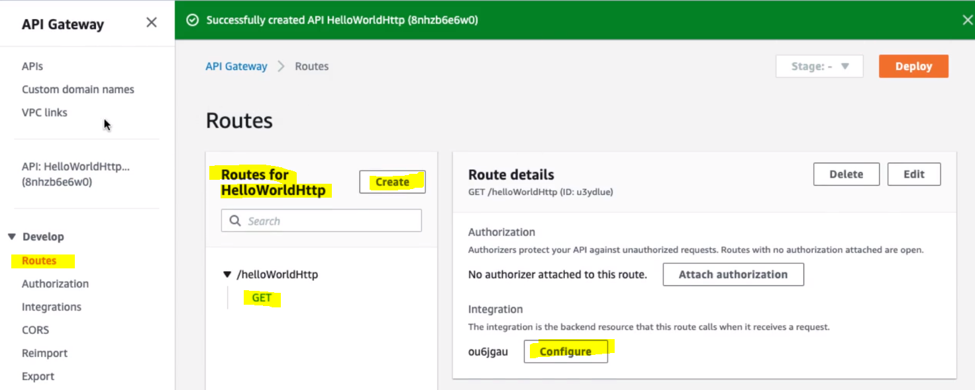

We can check the integrated lambda function by clicking configure

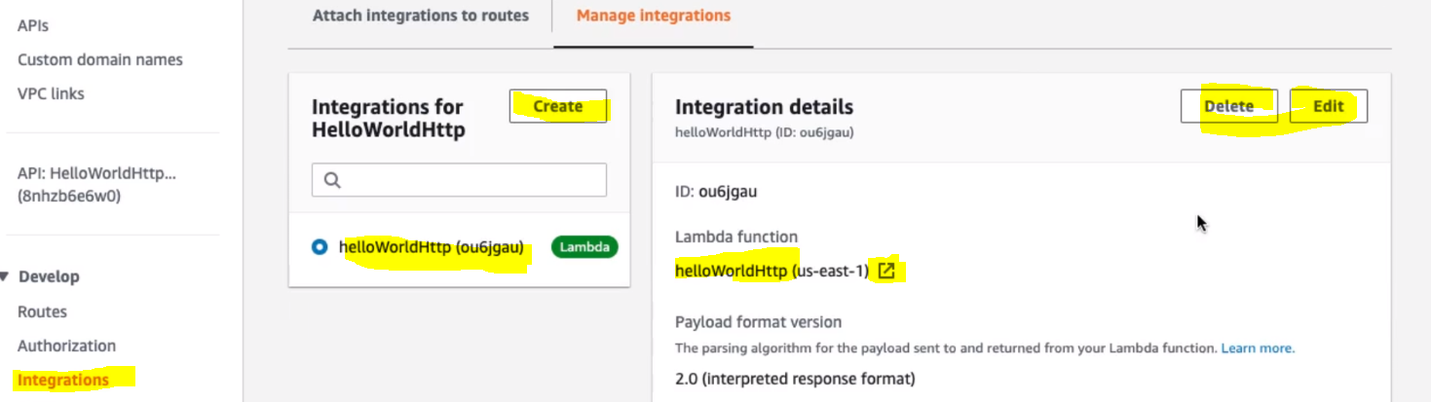

We can directly go to particular lambda function we can edit or delete and create a new lambda function and integrate.

We can create Post route: as given below.

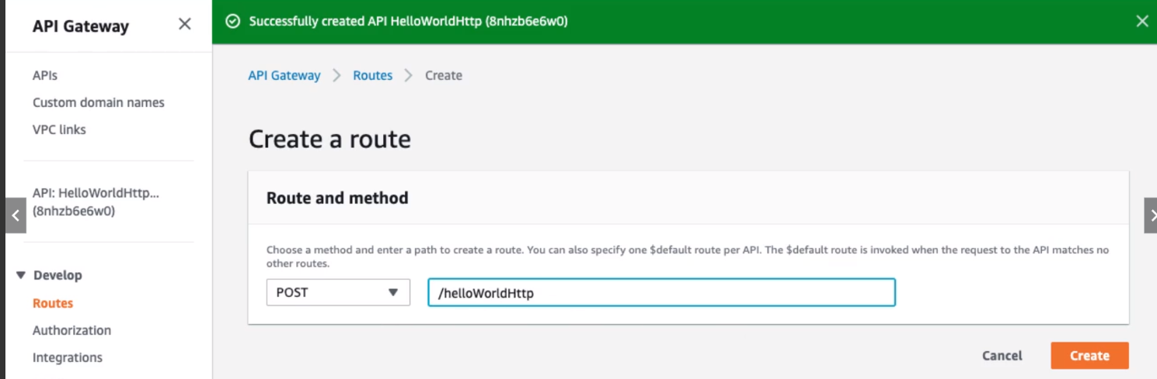

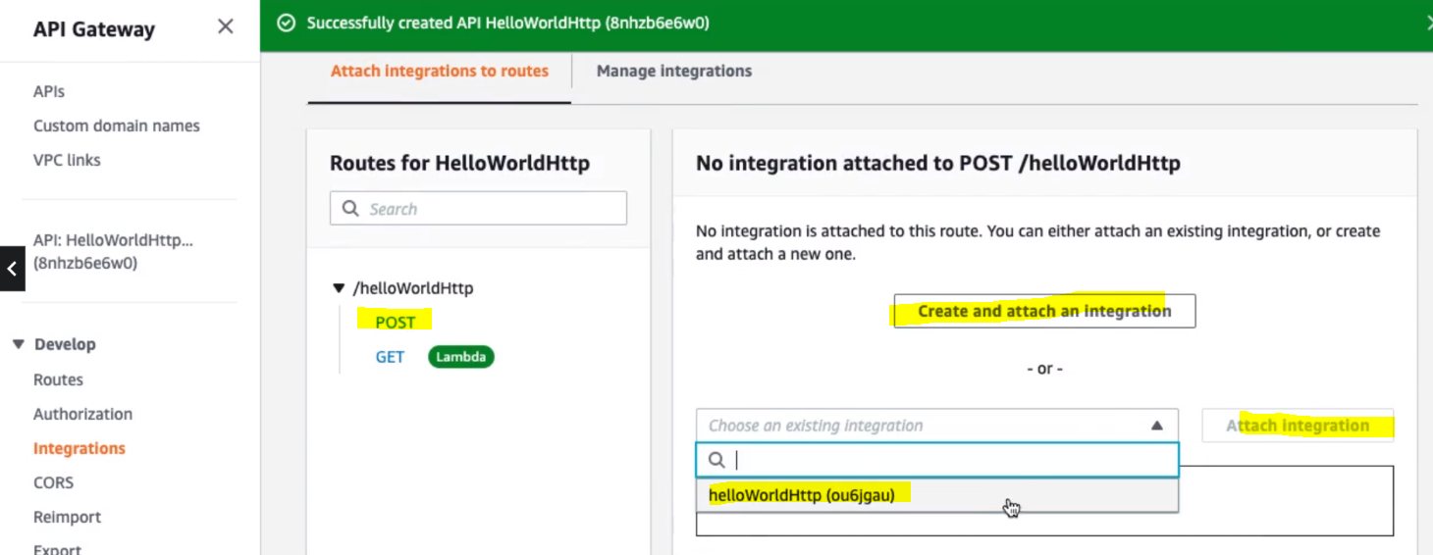

We can create a new integration or we can choose the existing one. Click on Attach Integration.

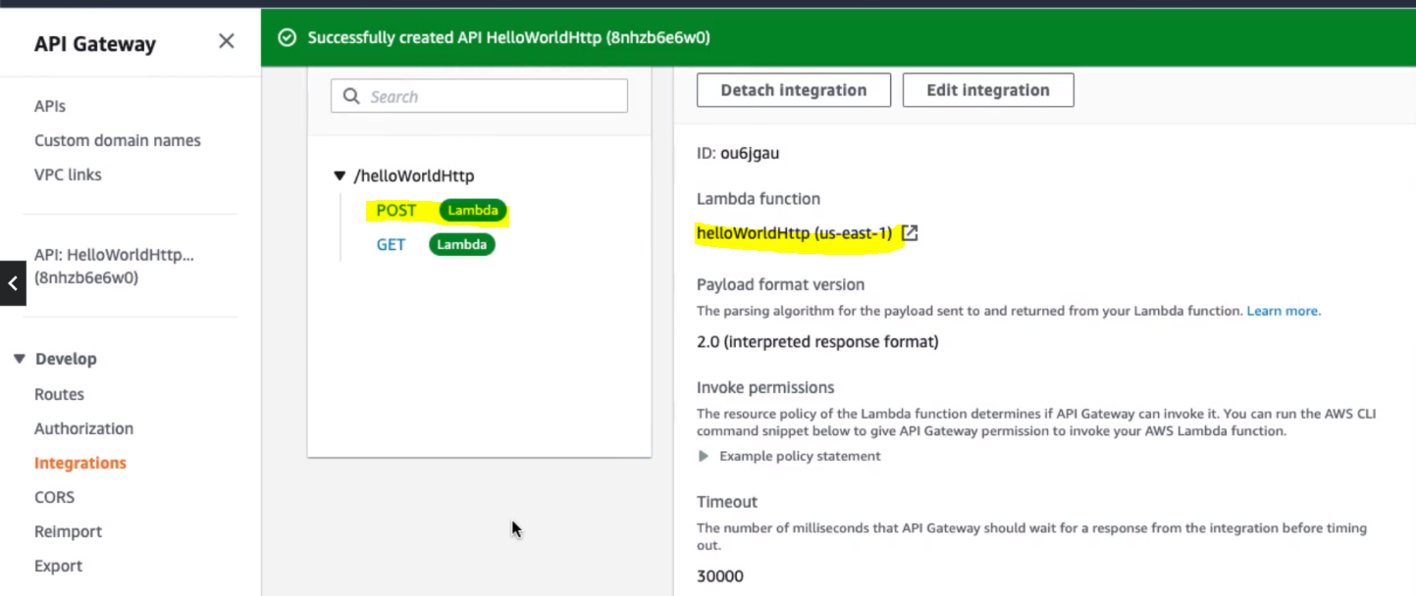

Finally we have created the Post method and resource and integrate the Post with the lambda function.

Now let’s test.

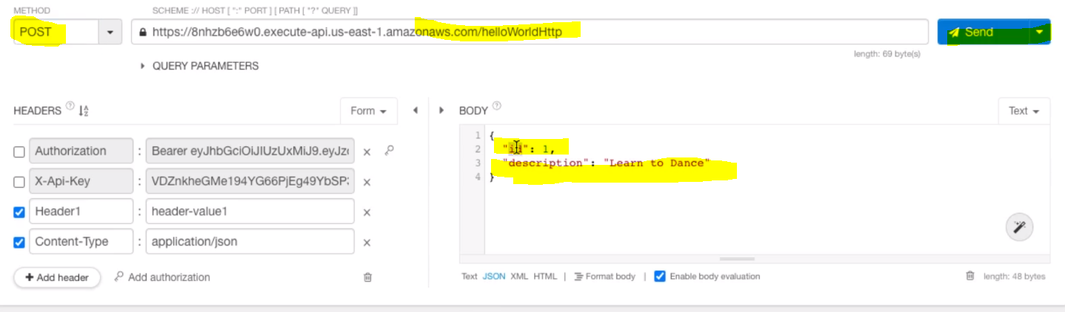

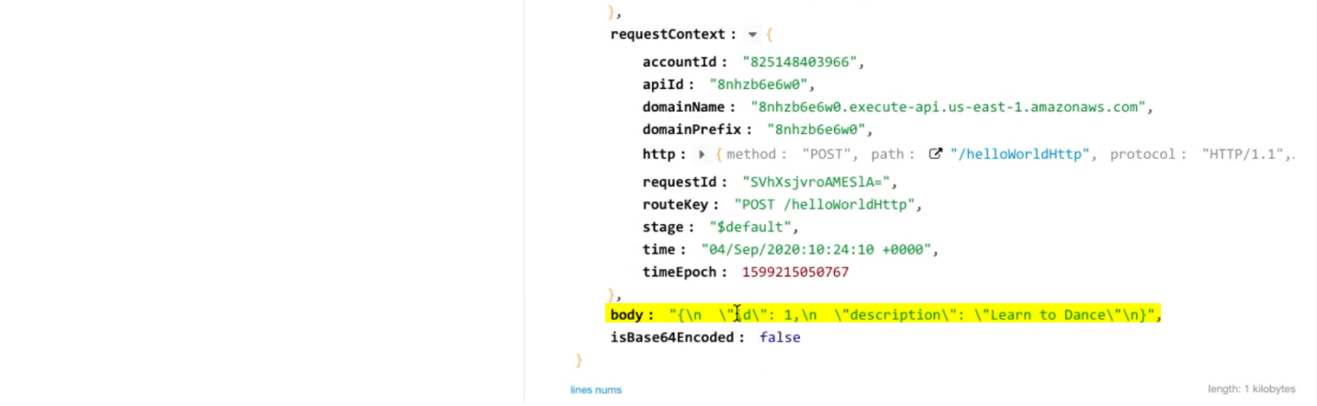

And we have got the response for POST request also.

**101. Step 19 - Exploring HTTP API - AWS API Gateway Further**

**Exploring API Gateway in Depth:**

In the last steps we have got to know different kind of API Gateway like: REST API & HTTP API. And we have also looked multiple type of integration. [like Custom integration & Proxy Integration]

Let’s talk more about API Gateway:

**102. Step 01 - Exploring API Gateway Endpoint Types**

There are three types of Endpoint of API Gateway can be created.

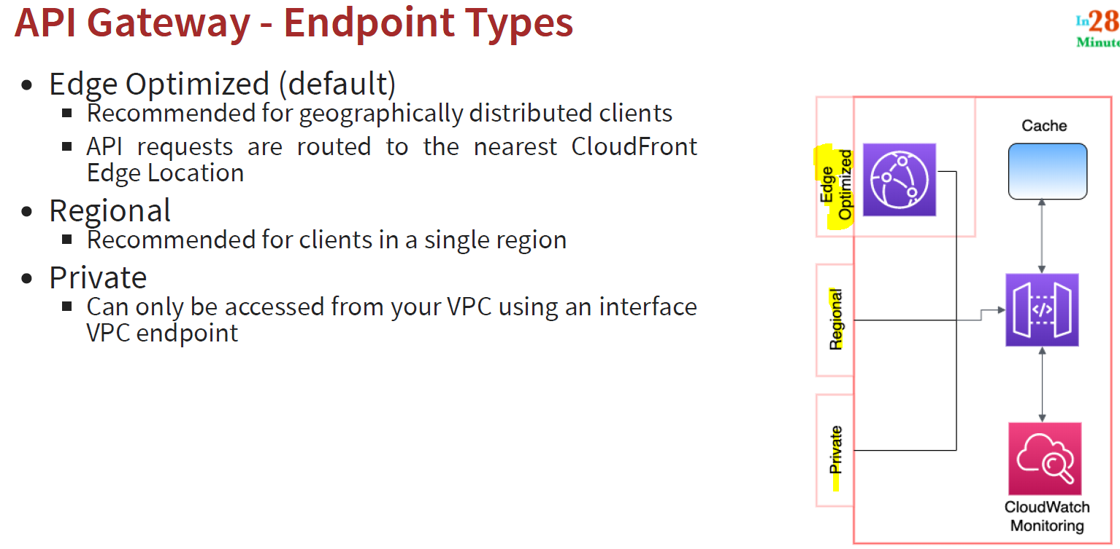

**Edge**: If our application is deployed on all around the world: (we have more than 200 edge location)

**Regional**: If our application is deployed to the specific region (e.g. Mumbai Region)

**Private**:

We can choose these (one of them during creation of New API

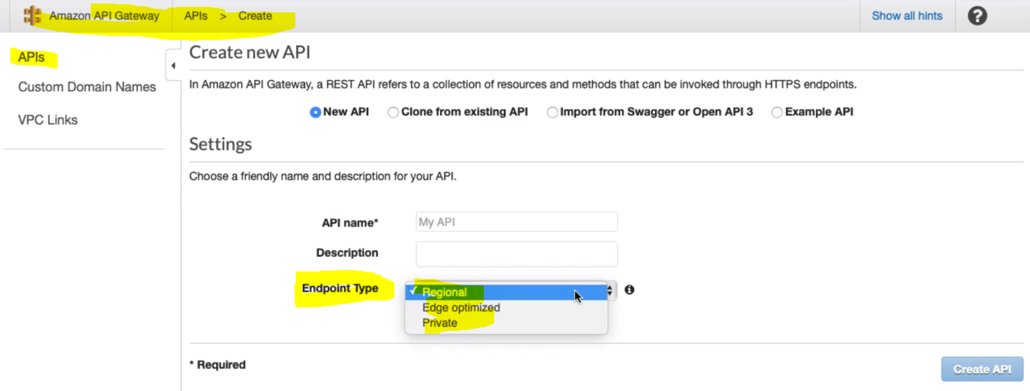

If we hover on (i) mark

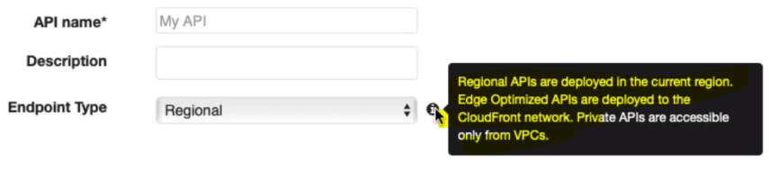

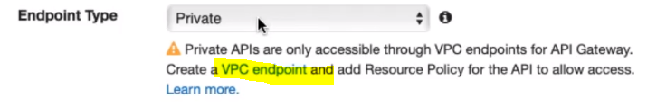

**103. Step 02 - Exploring API Gateway Integration Types**

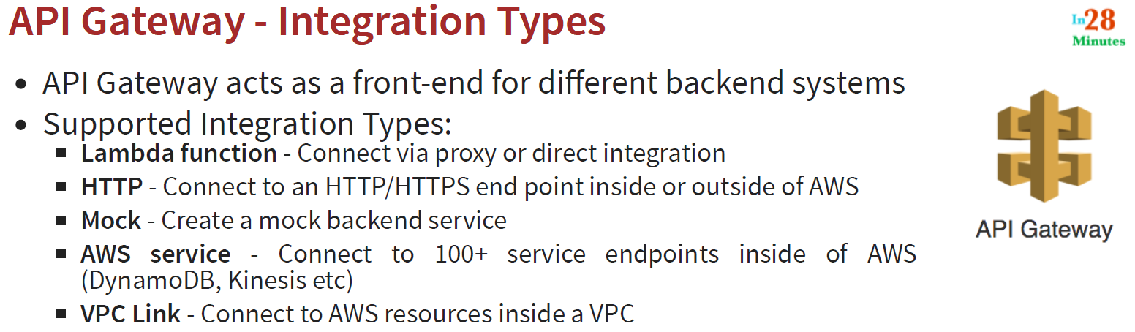

**HTTP**: If we have already existing web service which is exposed using http or https then we can connect or integrate from an API Gateway.

We can integrate from this screen

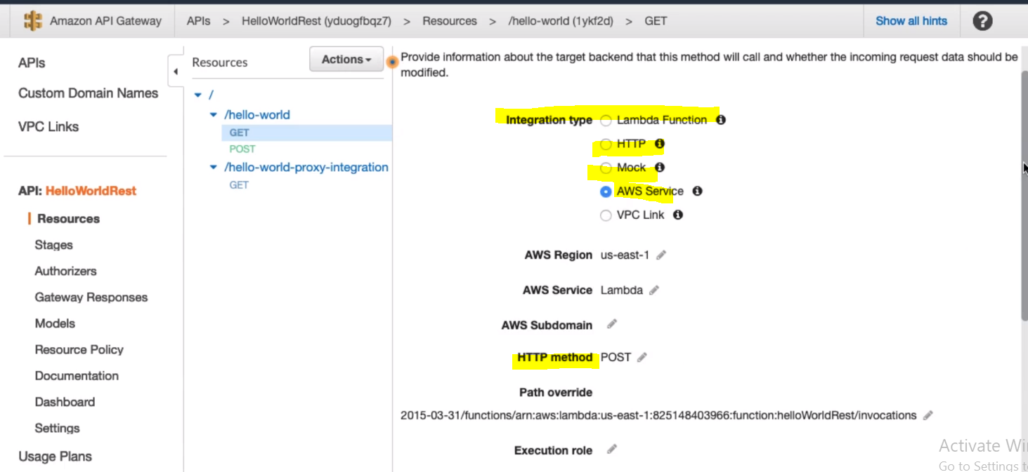

**104. Step 03 - Exploring API Gateway Lambda Integrations - Custom and Proxy**

Earlier when we were talking about integrating REST API with Lambda then we talked about two integration. 1- Custom Integration 2- Proxy Integration 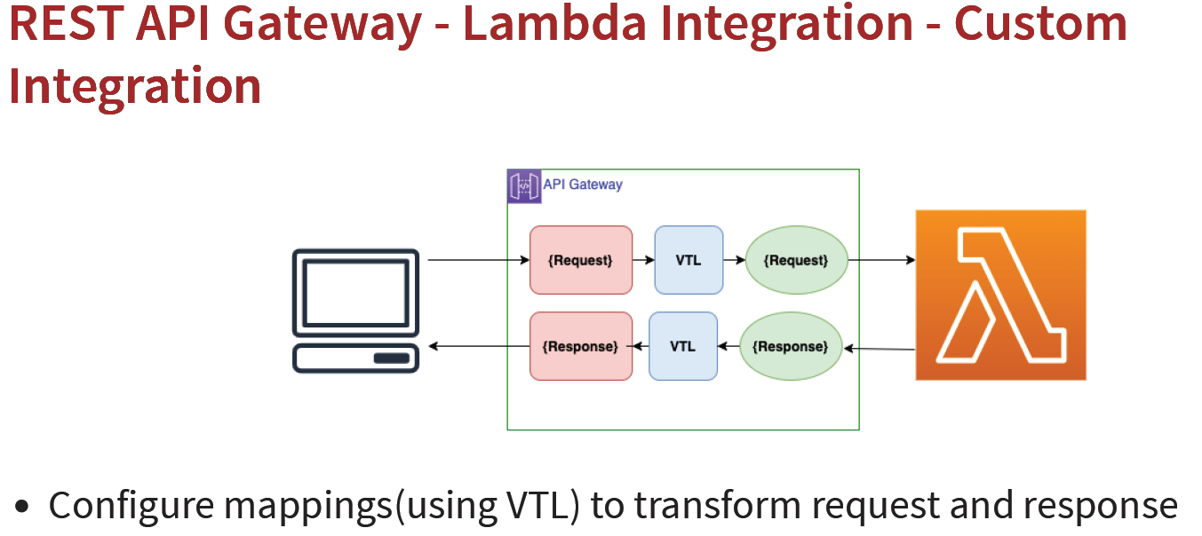

With Custom Integration we can configure mapping to transform request and response. So whatever request comes from the API Gateway, we can custom those request using (VTL) velocity template language and we can transform to different request and same thing we can do for response also i.e. take the response customize it using VTL and send it to user. The mapping can be define in the Integration Request & Integration Response.

Configure Request Using Mapping Template:

**Go to > Method Execution >**

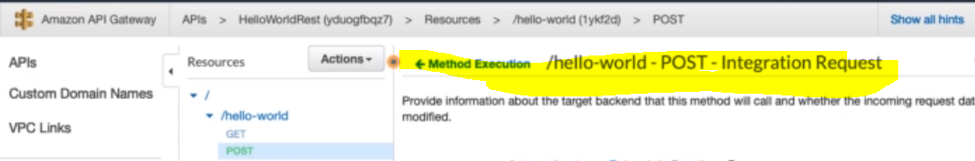**Scroll down on this page to Mapping Templates: Add your Mapping template:**

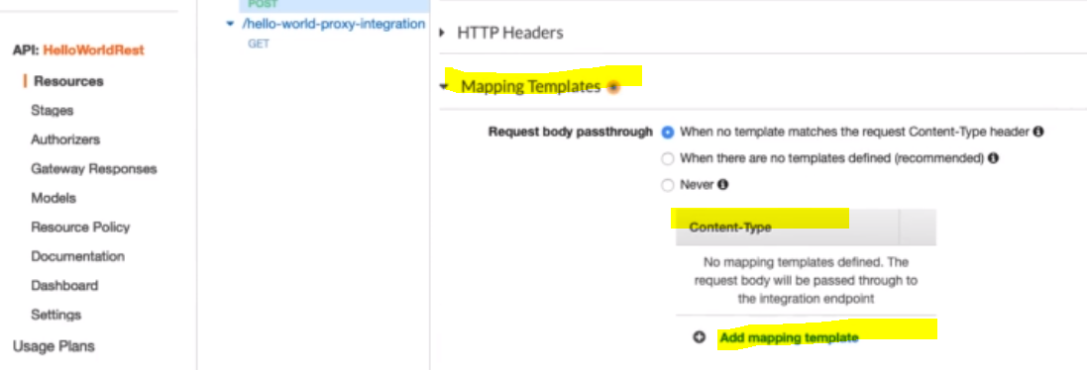 **Same thing we can do for response also:**

**Go to Method execution of the REST API > Go to Integration Response > Go to Mapping Templates > Add your template:**

**So this is about custom integration**

**Now let’s talk about proxy integration:**

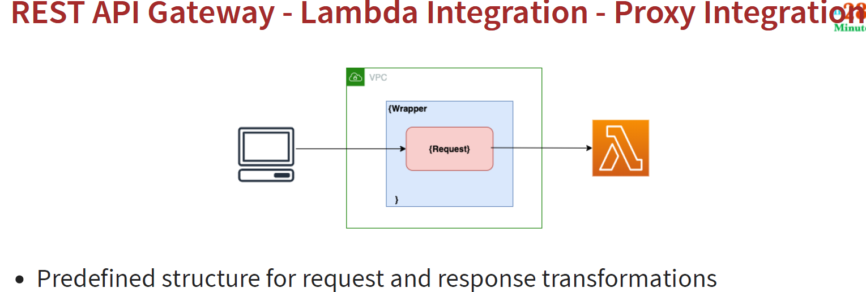

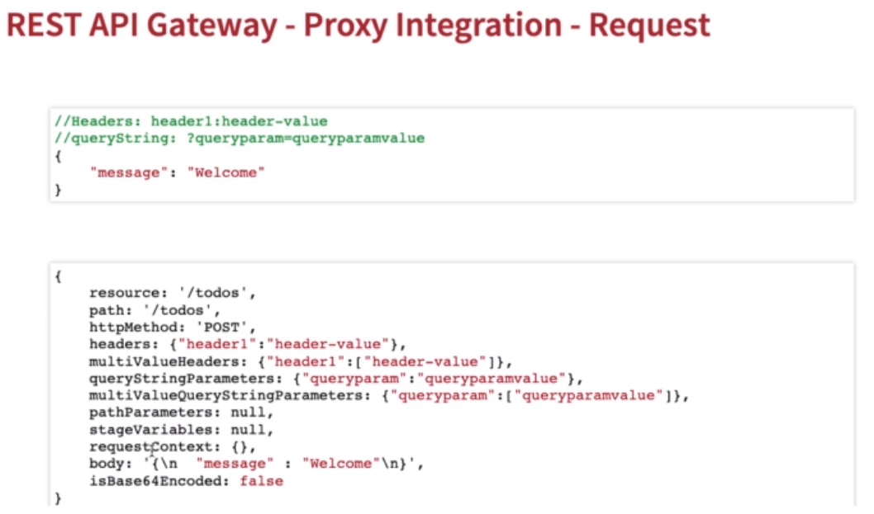

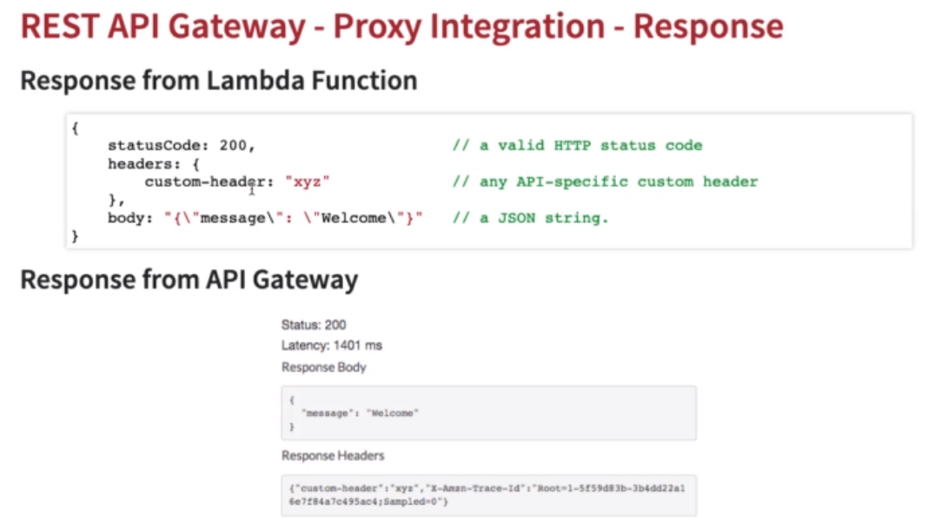

**105. Step 04 - Exploring API Gateway – Stages**

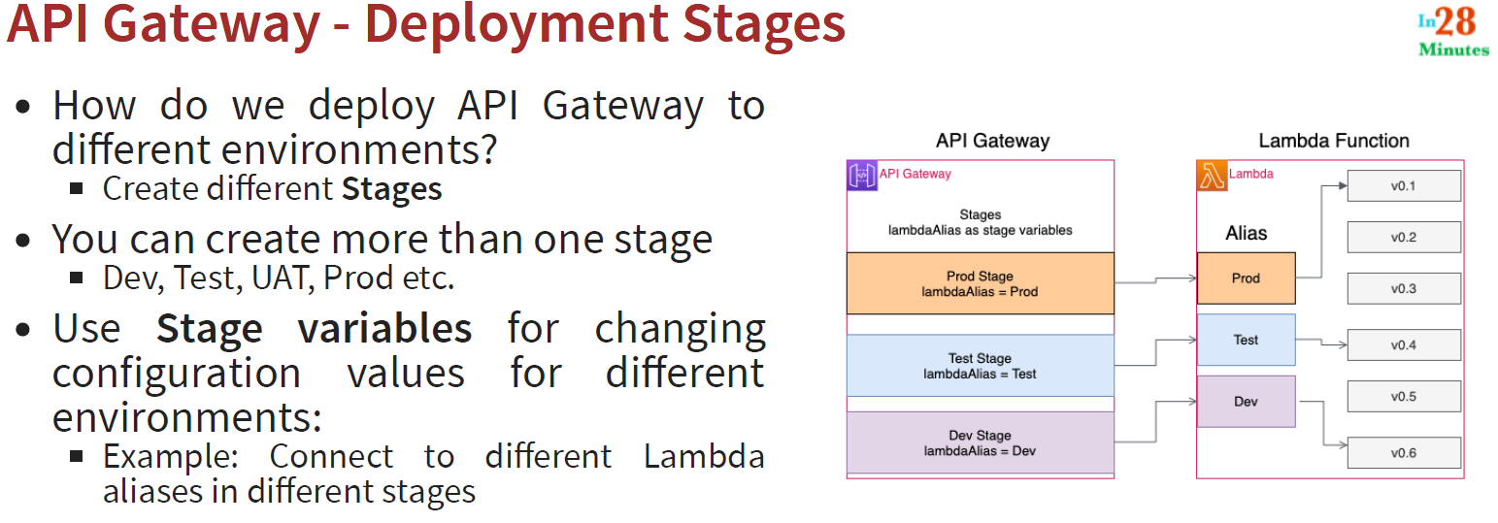

**106. Step 05 - Exploring API Gateway – Caching**

